REPUBLIC OF CAMEROON  Peace - Work - Fatherland | REPUBLIQUE DU CAMEROUN  Paix – Travail - Patrie
 | 
AFRICAN INSTITUTE OF COMPUTER SCIENCES - CAMEROON OFFICE  PAUL BIYA TECHNOLOGICAL CENTER OF EXCELLENCE  P.O. Box: 13719 Yaoundé  Tel: +237.242.729.957 Fax: 22729958  E-mail: contact@iaicameroun.com  Web site: www.iaicameroun.com | REALIZE  Tel: (237) 620256960/654486985  Email : realize.contactus@gmail.com  Web site: www.realize.cm
THEME:DESIGN AND IMPLEMENTATION OF AN AI-ASSISTED PHARMACY STOCK MANAGEMENT PLATFORM WITH GEOLOCATION-BASED DRUG SEARCH AND DELIVERY SERVICE

Internship carried out from the 01st of July till the 30th of September 2026. In view of obtaining a Software Engineering Diploma in Computer Sciences Option: Software Engineering
Written by:
NSAN SAMUEL PENIEL
Level III Software Engineering student

Supervision:

Academic Supervisor:
Mr. ASANE DERICK
Lecturer at AICS-Cameroon
AICS-Cameroon
Professional Supervisor:
Mr. MENGOT NSO
Software Engineer

Academic Year 2025 – 2026

0

DEDICATION

TO THE DIBANGO FAMILY

ACKNOWLEDGEMENTSTO THE DIBANGO FAMILY

ACKNOWLEDGEMENTS

As a prelude to this internship report, we would like to express our sincere gratitude to all individuals and entities whose guidance, support, and encouragement have contributed to the successful completion of this work and to a productive academic year. We are particularly grateful to:
- Mr. ARMAND CLAUDE ABANDA, the Resident Representative of the African Institute of Computer Sciences, for his wise and invaluable instructive advice.
- Mr. MENGOT NSO, our professional supervisor, for his help, advice, and encouragement that greatly supported the successful development of this project.
- Mr. ASANE DERICK, our academic supervisor and lecturer at AICS Cameroon, for his constant guidance, advice, and moral support during our academic and internship journey, which contributed to the realization of this project.
- The Administrative and Teaching Staff of AICS Cameroon, for their dedication, teaching, and guidance throughout the 2023-2026 academic year.
- Our families and parents, for their spiritual, moral, and financial support, which was instrumental in enabling us to complete this work.
- Lastly, all other individuals and organizations who contributed in one way or another to the realization of this project.

CONTENT

DEDICATION i
ACKNOWLEDGEMENTS ii
CONTENT iii
LIST OF FIGURES iv
LIST OF TABLES vi
LIST OF ABBREVIATIONS vii
ABSTRACT viii
RESUME ix
GENERAL INTRODUCTION - 1 -
PART 1 : INSERTION PHASE - 2 -
PART 2 : TECHNICAL PHASE - 13 -
FILE 1: EXISTING SYSTEM - 14 -
FILE 2: SPECIFICATION BOOK - 22 -
FILE 3: ANALYSIS PHASE - 37 -
FILE 4: CONCEPTION PHASE - 73 -
FILE 5: CONCEPTION PHASE - 93 -
FILE 6: TEST OF FUNCTIONALITIES - 106 -
FILE 7: INSTALLATION GUIDE AND USER GUIDE - 114 -
PERSPECTIVES - 125 -
GENERAL CONCLUSION - 126 -
ANNEXES - 127 -
BIBLIOGRAPHY - 128 -
WEBOGRAPHY - 129 -

LIST OF FIGURES

Figure 1 : Realize Location - 7 -
Figure 2 Company functional organization (Source: Realize) - 9 -
Figure 3 : Project Gantt chart - 31 -
Figure 4 : UML 2.5 diagrams overview (source: https://creately.com/blog/diagrams/uml-diagram-types-examples/ ) - 41 -
Figure 5 :2TUP diagram (Source:https://www.mysciencework.com/omniscience/pervasive-mobile-healthcare-system-basedon - 42 -
Figure 6 : Use case formalism - 46 -
Figure 7 : General use case diagram - 49 -
Figure 8 : Activity diagram formalism - 55 -
Figure 9 : Authenticate activity diagram - 57 -
Figure 10 : Create account activity diagram - 58 -
Figure 11 : Search drug and Pharmacy activity diagram - 59 -
Figure 12 : Place Order activity diagram - 60 -
Figure 13 : Sequence diagram formalism - 61 -
Figure 14 : Sequence diagram of Authenticate - 63 -
Figure 15 : Search drug and Pharmacy - 64 -
Figure 16 : Place Order sequence diagram - 65 -
Figure 17 : Communication diagram formalism - 66 -
Figure 18 : Authenticate Communication diagram - 67 -
Figure 19 : Search drug and Pharmacy communication diagram - 68 -
Figure 20 : Place Order Communication diagram - 68 -
Figure 21 : Formalism of a state machine diagram - 69 -
Figure 22 : Account Creation State machine diagram - 71 -
Figure 23 : Order State machine diagram - 71 -
Figure 25 : The Physical Architecture Source - 79 -
Figure 26 : The Logical architecture - 85 -
Figure 27 : Class diagram formalism - 86 -
Figure 28 : Class diagram - 88 -
Figure 29 : Package diagram formalism - 89 -
Figure 30 : Package diagram - 91 -
Figure 31 : Component diagram formalism - 96 -
Figure 32 : Component diagram - 98 -
Figure 33 : Formalism of Deployment diagram - 99 -
Figure 34 : deployment diagram - 101 -
Figure 35 : Flutter logo - 102 -
Figure 36 : React and Vite logo - 102 -
Figure 37 : Node.js and Express.js - 103 -
Figure 38 : PostgreSQL logo - 103 -
Figure 39 : Prisma ORM logo - 103 -
Figure 40 : Supabase Storege logo - 104 -
Figure 41 : Gantt Project logo - 104 -
Figure 42 : Visual Paradigm logo - 104 -
Figure 43 : Postman logo - 104 -
Figure 44 : User registration and login code test - 111 -
Figure 45 : User registration and login test - 111 -
Figure 46 : Client Place Order test - 112 -
Figure 47 : Client Place Order test - 112 -
Figure 48 : Client Portal - 118 -
Figure 49 : Pharmacy Admin Portal - 119 -
Figure 50 : Cashier/Pharmacist Portal - 120 -
Figure 51 : Super Admin Portal - 121 -

LIST OF TABLES

Table 1 : Hardware resources (Source from REALIZE) - 10 -
Table 2 : Software resources (Source REALIZE) - 10 -
Table 3 : Limitations, Consequences and proposed solutions - 19 -
Table 4 : Chronogram of activities - 30 -
Table 5 : Software resources (source: MERCURIALE-2026) - 32 -
Table 6 : Hardware resources (source: MERCURIALE-2026) - 32 -
Table 7 : Human resources (source: Mercurial 2026) - 33 -
Table 8 : Global estimation - 33 -
Table 9 : List of participants - 34 -
Table 10 : Comparison between MERISE and UML - 44 -
Table 11 : Component of use case diagram Component of use case diagram - 47 -
Table 12 : Actors of our system - 48 -
Table 13 : Textual description formalism - 50 -
Table 14 : Textual description of Create account - 51 -
Table 15 : Textual description of search drug and pharmacy - 52 -
Table 16 : Textual description of Make Payment - 53 -
Table 17 : Component of an Activity diagram - 56 -
Table 18 : Component of sequence diagram - 62 -
Table 19 : Component of a communication diagram - 67 -
Table 20 : Component of state machine diagram - 70 -
Table 21 : Components of class diagram - 87 -
Table 22 : Component of package diagram - 90 -
Table 23 : Component of component diagram - 97 -
Table 24 : Component of deployment diagram - 100 -

LIST OF ABBREVIATIONS

- AICS: African Institute of Computer Sciences
- AI: Artificial Intelligence
- API: Application Programming Interface
- CSS: Cascading Style Sheets
- FCM: Firebase Cloud Messaging
- HTML: HyperText Markup Language
- ICT: Information and Communication Technologies
- JWT: JSON Web Token
- REST: Representational State Transfer
- TIC: Technologies de l'Information et de la Communication
- UI: User Interface
- UML: Unified Modeling Language
- URL: Uniform Resource Locator
- OTP: One-Time Password
- HTTPS: HyperText Transfer Protocol Secure
- ORM: Object-Relational Mapping
- GPS: Global Positioning System
- ETA: Estimated Time of Arrival

ABSTRACT

The rapid evolution of Information and Communication Technologies (ICT) has transformed several sectors, including healthcare, by enabling innovative solutions that improve access to essential medical services. In Cameroon, clients may face difficulties in identifying nearby pharmacies with the required medicines, verifying their actual availability, and arranging convenient pickup or delivery. In this context, digital platforms can improve pharmacy services by facilitating stock management, medicine search, order processing, and delivery. The African Institute of Computer Sciences Paul Biya Technological Centre of Excellence (IAI-Cameroon) promotes practical learning by combining academic training with hands-on project experience through internships. During my academic internship, I contributed to the development of PharmaGo, based on the theme “Design and Implementation of an AI-Assisted Pharmacy Stock Management Platform with Geolocation-Based Drug Search and Delivery Service.” The project involved feasibility studies, requirements analysis, UML modeling, design, implementation, and testing using the 2TUP process.PharmaGo provides pharmacy stock management, geolocation-based drug search, pharmacy location, order processing, prescription management, pickup and delivery services, and Mobile Money payment. The platform consists of a Flutter mobile application for clients, a web portal for pharmacy and administrative users, an Express.js backend, and a PostgreSQL database. Google Maps is integrated to support pharmacy location, nearby pharmacy search, routes, and estimated travel information. An AI assistant powered by the Gemini API provides advisory symptom-checking support while encouraging users to consult qualified healthcare professionals when necessary. Through these functionalities, PharmaGo aims to improve medicine availability, facilitate interaction between clients and pharmacies, and provide a more efficient and accessible pharmacy service in Cameroon.
Keywords: PharmaGo; Pharmacy Stock Management; Artificial Intelligence; Geolocation; Drug Search; Medicine Delivery; Flutter; 2TUP; Gemini API; Cameroon.

RESUME

L’évolution rapide des Technologies de l’Information et de la Communication (TIC) a transformé plusieurs secteurs, notamment celui de la santé, en permettant le développement de solutions innovantes destinées à améliorer l’accès aux services médicaux essentiels. Au Cameroun, les clients peuvent rencontrer des difficultés pour identifier les pharmacies proches disposant des médicaments recherchés, vérifier leur disponibilité réelle et organiser leur retrait ou leur livraison. Dans ce contexte, les plateformes numériques peuvent contribuer à améliorer les services pharmaceutiques en facilitant la gestion des stocks, la recherche de médicaments, le traitement des commandes et la livraison.L’Institut Africain d’Informatique, Centre d’Excellence Technologique Paul Biya (IAI-Cameroun), favorise l’apprentissage pratique en associant la formation académique à l’expérience acquise au cours des stages. Durant mon stage académique, j’ai contribué au développement de PharmaGo, réalisé suivant le thème « Conception et mise en œuvre d’une plateforme de gestion des stocks pharmaceutiques assistée par l’intelligence artificielle, avec recherche géolocalisée de médicaments et service de livraison ». Le projet a porté sur l’étude de faisabilité, l’analyse des besoins, la modélisation UML, la conception, l’implémentation et les tests suivant le processus 2TUP. PharmaGo intègre la gestion des stocks pharmaceutiques, la recherche géolocalisée de médicaments, la localisation des pharmacies, la gestion des commandes, la gestion des prescriptions, ainsi que les services de retrait en pharmacie et de livraison. La plateforme prend également en charge le paiement par Mobile Money. Elle repose sur une application mobile développée avec Flutter pour les clients, un portail web destiné aux utilisateurs pharmaceutiques et administratifs, un backend basé sur Express.js et une base de données PostgreSQL. Google Maps est intégré pour la localisation des pharmacies, la recherche des pharmacies proches,.
Mots-clés : PharmaGo ; Gestion des stocks pharmaceutiques ; Intelligence artificielle ; Géolocalisation ; Recherche de médicaments ; Livraison de médicaments ; Flutter ; 2TUP ; API Gemini ; Cameroun.

GENERAL INTRODUCTION

In today’s fast-paced world, technological advancements are transforming various sectors, including waste management. Digital innovations are helping cities and enterprises improve efficiency, reduce costs, and address environmental challenges. As a developing country, Cameroon is increasingly embracing the digital economy to boost growth and sustainability.To contribute to this progress, students at AICS Cameroon are required to undertake a three-month internship to apply their academic knowledge in real-world scenarios. During our internship at REALIZE, an IT solutions company, we were assigned the theme: “Design and Implementation of a Pharmacy Stock Management Platform with Geolocation-Based Drug Search and Delivery: Case of Cameroon.” Our project, PharmaGo, aims to design and develop a digital platform that improves pharmacy stock management while helping clients find medicines available in nearby pharmacies. The platform allows clients to search for drugs, identify nearby pharmacies, place orders, and choose between pharmacy pickup and delivery. To achieve these objectives, we conducted research and structured our work into the following parts:
- Insertion Document: Introducing the company and our internship experience, along with the project theme.
- Existing System: Analyzing current waste collection methods.
- Specification Book: Defining user needs, considering costs and deadlines.
- Analysis Document: Presenting analysis methods and diagrams for understanding the system.
- Conception Phase: Designing the overall and detailed architecture of the waste collection system.
- Realization Phase: Demonstrating how the system will be built and implemented.
- Functionality Testing: Highlighting the modules and how they operate.
- User Guide: Providing instructions for users to operate the system effectively.

PART 1 : INSERTION PHASE

Preamble
This report summarizes the company, the project we worked on, the tasks we completed, the tools used, and the results achieved during the internship.

Content Overview

INTRODUCTION
- WELCOME AND INTEGRATION
- GENERAL PRESENTATION OF REALIZE
- ORGANISATION OF REALIZE
- HARDWARE AND SOFTWARE RESOURCES
- BRIEF PRESENTATION OF THE PROJECT
CONCLUSION

INTRODUCTION
Insertion is the way in which man can integrate a community, a group. Within the framework of the academic internship, the insertion phase is a period in which the different interns have to know more about their host company. Additionally, we have to know about the staffs, the different hardware and software used, the different department, which constitute the company, and we were introduced to our workspace, how the company functions both internally (that is how the different task is schedule, the rules and regulations, working periods and so on). We also had a time to discuss amongst us interns on topics like what we love doing most, what we dislike, our believes, our best meals, sports, songs, our temperaments, our inborn talents and those we learn as we grow up. We shared about different realizations and failures in life.

WELCOME AND INTEGRATION
- Welcome
We arrived at REALIZE on Thursday, July 1, 2026, at 08:00. We were greeted by Mr. TANUE MONET, the Software Designer, and Mr. MENGOT NSO, the Senior Developer, who delivered an inspiring welcome and introduced the company’s operations and scheduling for our internship period. The initial meeting covered the challenges from the coding test required for the internship, REALIZE’s organizational structure and internal policies, and the allocation of workstations to each intern.
- Integration
First-week activities: We set up at our designated workstations and received our initial task. A foundational verification of concepts using HTML and CSS ensured all interns started on an even footing. We brainstormed project ideas, with an emphasis on individual initiative; prior experience helped me contribute and refine these ideas. We conducted research on the proposed ideas, as REALIZE encouraged initiative and did not prescribe themes.

Second-week activities: JavaScript concept verification exercises were used to assess understanding and reasoning. A detailed discussion with the supervisor reviewed the specification book and its components, clarifying expectations for each section. Project ideas were further developed into concrete plans, leveraging familiarity with REALIZE’s expectations and processes.

GENERAL PRESENTATION OF REALIZE

A. History
Realize is a Cameroon-based NGO and tech start-up founded by Mr. NDELOGAKEH Daniel in 2022. It offers IT solutions and promotes the use of new technologies in Cameroon.

B. What is REALIZE all about?

i. Missions
Realize mission is to empower and sustain the use of technology through:
- Designing mobile software for businesses and individuals
- Supporting startups for rapid growth using IT
- Providing training and certifications to build qualified human resources
- Contributing to global sustainable development with innovative solutions and virtual reality

ii. Vision
Realize believes that unlocking the potential of organizations and individuals is possible through analysis, development, realization, and data analytics. Their vision is to shape a future of limitless innovation in the digital world.

iii. Activities
Realize activities include:
- Designing and hosting websites
- Software development and maintenance
- Providing training in software fields
- Creating multimedia content
- Offering IT consulting, support, and innovation.

C. Geographical Location
REALIZE is located at Yaoundé-Valle Amadou
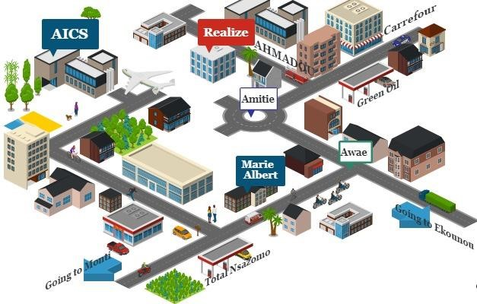
Figure 1: Realize Location

ORGANISATION OF REALIZE

A. Administrative Organization
Realize’s administrative structure is divided into several departments:

1. General Management
- Oversees the entire company
- Ensures departments function properly
- Sets project strategies
- Provides leadership and guidance
- Makes critical decisions impacting operations and reputation
- Acts as a point of contact for stakeholders like investors

2. Human Resources
- Handles recruitment and hiring
- Acts as a link between employees and management
- Manages salaries, benefits, and employee policies
- Maintains employee records and HR systems

3. Communication Department
- Manages public relations and company image
- Handles messaging to external stakeholders (customers, partners)
- Ensures effective internal communication
- Creates and manages content for various platforms

4. Financial Affairs
- Develops and manages budgets and financial plans
- Prepares financial reports for management and authorities
- Controls costs and expenses
- Ensures tax compliance

5. Technical Department
- Manages infrastructure like networks and hardware
- Handles data management and cybersecurity
- Maintains relationships with vendors and service providers

6. Software Engineering Department
- Develops and supports software applications
- Maintains software throughout its lifecycle
- Executes and evaluates project realization

B. FUNCTIONAL ORGANISATION OF REALIZE
The functional branch of realize is organized as follows:
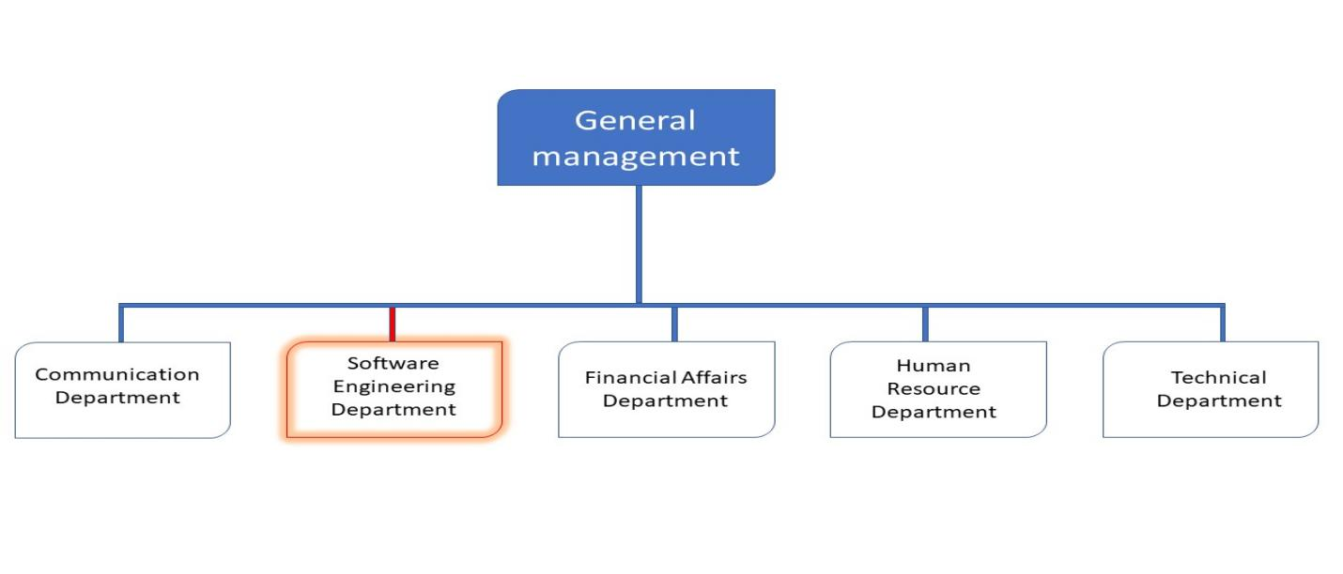
Figure 2 Company functional organization (Source: Realize)

HARDWARE AND SOFTWARE RESOURCES OF REALIZE
- HARDWARE RESOURCES
Table 1: Hardware resources (Source from REALIZE)
No | DESIGNATION | QUANTITY | CHARACTERISTICS | OBSERVATION
1 | MacBook Pro | 1 | APPLE | Good
2 | Modem | 1 | CAMTEL | Good
3 | LCD Screen | 1 | HP | Excellent
4 | Training equipment and office furniture | / | / | /
- SOFTWARE RESOURCES
Table 2 : Software resources (Source REALIZE)
DESIGNATION | SOFTWARE
Operation system | Windows 10, Mac OS, parrot Linux
Design tools | Photoshop
Integrated development environment  (IDE) | Visual studio code,
Text editor | Sublime text, notepad++
Database management system (DBMS) | MongoDB
Web browser | Google chrome, Microsoft edge
Document editor | Microsoft office word
Presentation | Microsoft office PowerPoint

BRIEF PRESENTATION OF THE PROJECT
During our insertion phase at REALIZE, we identified several themes addressing specific problems and introducing innovative technological solutions. After reviewing our initial ideas, our professional supervisor evaluated the proposed themes and provided recommendations to improve their relevance and feasibility. Following this evaluation, we selected the theme:“Design and Implementation of a Pharmacy Stock Management Platform with Geolocation-Based Drug Search and Delivery: Case of Cameroon.”This project, named PharmaGo, aims to improve pharmacy stock management and facilitate access to medicines in Cameroon through a digital platform. The system will allow clients to search for medicines and identify nearby pharmacies where the requested drugs are listed as available. Clients will also be able to view pharmacy information, place orders, upload prescriptions when required, and choose between pharmacy pickup and delivery.On the pharmacy side, the Pharmacy Admin will be able to manage drug stocks by adding, updating, and removing medicines and their quantities. The Pharmacist/Cashier will review incoming orders, verify prescriptions when necessary, and manually confirm the actual availability of the requested medicines before an order is finalized.For delivery, each pharmacy will manage its own Delivery Agents, who will receive assigned delivery orders and update their delivery status. The Platform Admin will supervise the overall platform by managing users and pharmacies, monitoring orders and transactions, handling disputes, and viewing platform information.Through these functionalities, PharmaGo seeks to make pharmacy stock information more organized and accessible while simplifying the process of finding, ordering, and receiving medicines.

CONCLUSION
The insertion phase at REALIZE established the foundation for our internship, enabling rapid integration into the Software Engineering host unit and a clear understanding of the organization’s structure, workflows, and resources. We completed initial HTML/CSS exercises to validate core concepts and began shaping project ideas, preparing us to transition from onboarding to hands-on work. The phase culminated in the shift toward conceiving and implementing a waste collection system, setting the stage for practical design, stakeholder engagement, and scalable, impact-driven development.

PART 2 : TECHNICAL PHASE

FILE 1: EXISTING SYSTEM

Preamble
This section explains the existing system we are studying and outlines the app we will build. It describes how the existing system works, where it falls short, and the problems this causes. It then presents practical fixes and the initial steps to implement them.

Content Overview
INTRODUCTION
- THEME PRESENTATION
- DESCRIPTION OF THE EXISTING SYSTEM
- LIMITATIONS OF THE EXISTING SYSTEM
- PROBLEMATIC
- PROPOSED SOLUTION
CONCLUSION

INTRODUCTION
In this part of our report, we will explain our theme. We will also study the current system and identify its strengths and weaknesses. Based on this analysis, we will present the problem statement, which is the main challenge or gap that the current system faces. Finally, we will propose a solution that addresses this problem and improves the system.

THEME PRESENTATION
Our theme, “Design and Implementation of a Pharmacy Stock Management Platform with Geolocation-Based Drug Search and Delivery: Case of Cameroon”, focuses on designing and developing a digital platform to improve how pharmaceutical stock is managed and how clients access medicines from nearby pharmacies. The system connects clients, pharmacies, Pharmacy Staff, delivery agents, and the platform administrator through an intuitive digital platform. It addresses important limitations in traditional pharmacy services, particularly the difficulty of knowing whether a specific medicine is available before travelling to a pharmacy, as well as the challenges associated with ordering and delivery. The conception phase involves analysing existing pharmacy stock management and medicine procurement practices, identifying limitations such as inaccurate or non-real-time stock information, difficulty locating nearby pharmacies, limited order tracking, manual prescription verification, and difficulties accessing medicines through delivery services, and proposing a digital solution adapted to the Cameroonian context.The implementation phase consists of developing an Android-first mobile application for clients and a web-based dashboard for Pharmacy Staff and the Platform Admin, supported by a common backend API. The platform enables clients to search for medicines, activate their GPS location, identify nearby pharmacies with the requested medicine listed in stock, view pharmacy information and route details, request orders, upload prescriptions when required, choose between pickup and delivery, make payments using Mobile Money or Cash on Delivery, and track their orders.

DESCRIPTION OF THE EXISTING SYSTEM
In Cameroon, access to medicines generally depends on clients physically visiting pharmacies or contacting them individually to determine whether a particular medicine is available. Pharmacy personnel are responsible for managing medicine stocks, receiving clients, verifying prescriptions when necessary, processing sales, and handling other pharmacy operations. In the traditional approach, stock management is mainly handled internally by each pharmacy. Pharmacy staff record and monitor available medicines and their quantities. However, clients generally do not have direct access to this information before visiting the pharmacy. Consequently, a client who needs a specific medicine may have to visit or contact several pharmacies before finding one that has it available. This situation becomes more problematic when the medicine is urgently required or when the client is located far from the pharmacy. Clients may spend significant amounts of time and transportation costs searching for medicines that may eventually be unavailable. Pharmacies also face operational challenges. Stock information may not always be updated immediately after a medicine is sold or received. This can result in differences between the quantity recorded in the pharmacy's stock and the quantity actually available. For this reason, simply displaying stock information to a client cannot always guarantee actual availability. The traditional system also provides limited support for geolocation-based pharmacy discovery. Clients may know the name of a pharmacy but still have difficulty determining which pharmacy is closest, whether it is currently open, or how long it would take to reach it. Furthermore, the process of ordering medicines remotely is not always centralized. Clients may need to call or communicate directly with pharmacies, while order confirmation, prescription verification, payment and delivery may be handled through separate manual processes.

LIMITATIONS OF THE EXISTING SYSTEM
Table 3 : Limitations, Consequences and proposed solutions
Limitations | Consequences | Proposed Solutions in PharmaGo
No centralized digital access to pharmacy stock information | Clients must contact or visit several pharmacies to find a medicine | A digital stock management platform allowing pharmacies to maintain their medicine stock and clients
Stock information may be outdated or inaccurate | Clients may travel to a pharmacy only to discover that the medicine is unavailable | Pharmacy Staff manually confirm actual availability before an order is finalized
Difficulty locating nearby pharmacies | Clients spend additional time and transportation costs searching for medicines | GPS-based pharmacy discovery using Google Maps
Limited digital ordering | Clients may need to contact pharmacies manually to request medicines | Digital order request through the mobile application
Manual prescription management | Prescription verification can be slow and difficult to track | Digital prescription upload and verification by Pharmacy Staff
Limited payment options within the platform | Payment may require separate manual processes | Integration with Mobile Money payment gateway and Cash on Delivery
Limited coordination of pharmacy deliveries | Delivery preparation and assignment may be difficult to monitor | Digital delivery assignment to the pharmacy's own delivery agents
No centralized history of orders | Clients and pharmacies have limited access to previous transactions | Digital storage of order and transaction history
Limited access to health information | Clients may lack basic health-related guidance | Health tips section within the platform
No integrated advisory symptom-checking tool | Clients may have difficulty deciding whether to seek professional medical advice | Advisory-only AI symptom checker that encourages consultation with a healthcare professional

PROBLEMATIC
How can a digital pharmacy stock management platform improve the visibility and reliability of medicine availability while enabling clients to locate nearby pharmacies, request and confirm orders, and obtain medicines through pickup or pharmacy-based delivery?

PROPOSED SOLUTION
The proposed solution is PharmaGo, a digital pharmacy stock management platform designed to improve medicine availability visibility and facilitate access to medicines in Cameroon. The platform combines pharmacy stock management, geolocation-based medicine search, digital ordering, prescription management, payment, and pharmacy-based delivery within a unified system.

1. Pharmacy Stock Management and Geolocation of a pharmacy
The platform provides Pharmacy Staff with a web dashboard for managing pharmacy stock. The stock information is then used by the system when clients search for medicines.

2. Order Request and Human Confirmation
After finding a suitable pharmacy, the client selects the medicine and quantity and submits an order.

3. Delivery and Payment Management
Mobile Money processing can be demonstrated using a sandbox or simulated payment flow during the academic defense.

4. Order Tracking and Notifications
The platform allows clients to follow the progress of their orders and For delivery orders, the system can use route information to support delivery tracking.

CONCLUSION
In conclusion, the current waste collection system faces challenges in efficiency, accessibility, and payment management, particularly in hard-to-reach areas. The proposed digital solution, combining a mobile app, GPS tracking, online payments, and integrated management tools, offers a practical and effective way to optimize waste collection, ensure timely service, and improve overall transparency and customer satisfaction.

FILE 2: SPECIFICATION BOOK

Preamble
The primary goal of the specification book is to outline with great precision the requirements or need of the users and the description of the resources necessary to realize the project. The project's success will depend on careful allocation and management of the various resources available, including physical, financial, and human assets. Therefore, this document outlines the criteria that the developer must adhere to in order to ensure the success of the project.

Content Overview

INTRODUCTION
- CONTEXT AND JUSTIFICATION
- OBJECTIVES OF THE PROJECT
- EXPRESSION OF NEEDS
- PROJECT PLANNING
- PROJECT ESTIMATION COST
- PROJECT CONSTRAINTS
- LIST OF PARTIPANTS AND DELIVERABLES
CONCLUSION

INTRODUCTION
The report's specification book enables us to provide comprehensive details about our topic, enhancing our understanding and improving its chances of success. To establish the project's scope, we will describe the context of our topic and identify the issues within it that we aim to solve. Once the solution is proposed, we will outline the objectives we have set for ourselves and for the project. It establishes a certain agreement between the client of the project and the person who is supposed to realize the project. It presents the objectives and needs of the system to be developed. The present specification book relates to the context and justification, the needs of the project, the plan and the deliverables.

CONTEXT AND JUSTIFICATION

Context
Cameroon has a growing population and an expanding urban environment, particularly in major cities such as Yaoundé, Douala, and Bafoussam. This growth is accompanied by increasing demand for accessible and reliable healthcare services, including timely access to medicines. Although pharmacies are widely distributed in urban areas, obtaining a specific medicine can still be difficult when clients do not know which nearby pharmacy has the required product in stock. In the traditional pharmacy environment, clients generally have to visit or contact pharmacies individually to determine whether a medicine is available. This process becomes particularly inconvenient when a medicine is urgently needed or when the client is located far from the pharmacy. Another important challenge concerns pharmacy stock management.
Key challenges include:
- Limited stock visibility: Clients generally cannot easily determine which nearby pharmacy has a particular medicine available.
- Difficulty locating pharmacies: Clients may spend time searching for pharmacies that are close to their current location.
- Unnecessary travel: A client may travel to a pharmacy only to discover that the required medicine is unavailable.
- Outdated stock information: Pharmacy stock records may not always reflect the actual physical quantity available.
- Limited digital ordering: Medicine requests are often handled through physical visits, telephone calls, or informal communication channels.
- Prescription management difficulties: Prescription verification may still depend on manual processes.

Justification
The justification for developing a computerized pharmacy stock management platform such as PharmaGo lies in addressing the limitations associated with traditional medicine-searching, stock-management, ordering, and delivery processes.
The digitalization of these processes will:
- Improve pharmacy stock visibility by allowing Pharmacy Staff to maintain updated information about medicines and quantities.
- Reduce unnecessary trips by enabling clients to search for a medicine and identify nearby pharmacies before travelling.
- Improve the reliability of availability information through the required human confirmation step, whereby Pharmacy Staff verify the actual availability of the requested medicine before the order is finalized.
- Facilitate geolocation-based pharmacy discovery by using Google Maps to identify nearby pharmacies and provide their location, open/closed status, route, ETA, and travel time.
- Simplify medicine ordering by allowing clients to submit orders directly through the mobile application.
- Facilitate prescription management by allowing clients to upload prescriptions and Pharmacy Staff to verify them digitally.
- Improve access to medicines by providing both pharmacy pickup and pharmacy-based delivery options.
- Improve payment convenience through Mobile Money and Cash on Delivery.
- Increase transparency by allowing clients to follow the status of their orders.

OBJECTIVES OF THE PROJECT

General Objective
To design and implement a digital pharmacy stock management platform that improves medicine availability visibility and facilitates the geolocation-based search, ordering, confirmation, ai symptom checker and delivery of medicines in Cameroon.

Specific Objectives
The specific objectives of this project are to:
- Develop a pharmacy stock management module allowing Pharmacy Staff to add, update, remove, and monitor medicine stock records.
- Facilitate medicine search by allowing clients to search for a specific medicine through the mobile application.
- Integrate Google Maps services to provide pharmacy locations, open/closed status, routes, ETA, and travel time within the approved scope.
- Implement a digital ordering process allowing clients to request medicines from a selected pharmacy.
- Facilitate prescription management by allowing clients to upload prescriptions and Pharmacy Staff to verify them when required.
- Provide pickup and delivery options according to the client's preference.
- Support pharmacy-based delivery management by allowing delivery agents belonging to pharmacies to receive and update delivery assignments.
- Provide payment management supporting Mobile Money and Cash on Delivery.
- Provide order tracking and history so that clients can monitor their current and previous orders.
- Provide health information and an advisory symptom checker while ensuring that the AI feature does not provide medical diagnoses.

EXPRESSION OF NEEDS

1. Functional Needs
In this context, functional requirements describe what the PharmaGo system should do. The principal modules are organized according to the different actors and system responsibilities.

A. Client
The Client should be able to: Request an order, make payment, Use the ai symptom checker and geolocation of a pharmacy.

B. Pharmacy Admin
The Pharmacy Admin should be able to: Register and manage the pharmacy, Manage stock, Manage pharmacy schedules, Manage delivery agents, Monitor orders.

C. Pharmacist / Cashier
The Pharmacist/Cashier should be able to: View incoming order requests, Confirm actual medicine availability, Accept or reject an order, Verify prescriptions, Update order status.

D. Delivery Agent
The Delivery Agent should be able to: View assigned deliveries, View delivery information, Update delivery status.

E. Platform Admin
The Platform Admin should be able to: Manage user accounts, Manage pharmacies, Monitor orders, Monitor transactions, Manage disputes, Manage health tips, Monitor platform.

External Services
PharmaGo also interacts with external services.

Google Maps API
The system uses Google Maps for the approved geolocation functions: locating nearby pharmacies, obtaining pharmacy location information, providing routes, calculating ETA, providing travel time.

Mobile Money / Payment API Gateway
The payment service processes Mobile Money transactions. The project may use a sandbox or simulated payment process for academic demonstration.

Non-Functional Needs
Non-functional requirements define the quality characteristics and constraints that PharmaGo must satisfy to ensure that the platform is secure, reliable, usable, and maintainable.

a. Performance Requirements
- The system should respond efficiently to requests from clients, Pharmacy Staff, Delivery Agents, and the Platform Admin.

b. Security Requirements
- User credentials must be securely protected and authentication and authorization mechanisms must be implemented for all user roles, Role-Based Access Control (RBAC).

c. Reliability and Availability
- PharmaGo should remain available to clients and pharmacy personnel under normal operating conditions.

Chronogram of activities
Table 4: Chronogram of activities
PHASE | OBJECTIVE | OUTPUT | DURATION | PERIOD
INSERTION | Collection of information on the enterprise | Insertion book | 2 weeks | 01rd July to 14th July
EXISTING SYSTEM | Study of the existing system | Existing System | 1 week | 14nd July to 22nd July
SPECIFICATION BOOK | Specification of the user needs | Specification Book | 1 week | 23rd July to 30rd July
ANALYSIS | Capture of needs Use case and textual description Modelling | Analysis Book | 2 weeks | 31st July to 13th August
CONCEPTION | Preliminary conception and Detailed conception | Conception book | 1 weeks | 14th August to 26st August
REALIZATION | Implementation Unitary test Integration Test Development | Realization book | 2 weeks | 27th August to 10th September
TEST OF FUNCTIONALITIES | Testing of the software and debugging | Test of functionalities | 2 week | 11th September to 24th September
INSTALLATION AND USER GUIDE | Documenting software | User Guide | 1 week | 26th September to 30th September

  - Gantt Project Planning
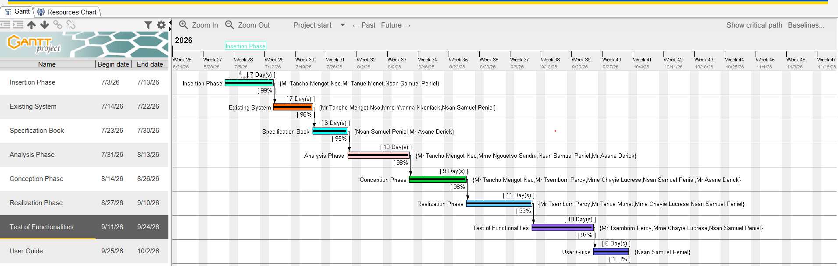
Figure 3: Project Gantt chart

PROJECT ESTIMATION COST
- Software Resources
Table 5 : Software resources (source: MERCURIALE-2026)
RESOURCES | DESIGNATION | USAGE | QUANTITY | UNIT COST (FCFA)
Formatting | MICROSOFT OFFICE PROFESSIONAL 2016 | Writing of the report | 1 | 355,465
Web browser | Google Chrome | Access and view web pages on the internet | 1 | Freeware
Code Editor | Visual Studio Code | For writing the code of the application | 1 | Freemium
Project Planning | Gantt Project | For building a Gantt chart | 1 | Freemium
UML Analysis | Visual Paradigm | For drawing UML diagrams | 1 | Community Version
Version Control | Git & GitHub | For tracking and managing changes to software code | 1 | Free Version
TOTAL 1 |  |  | 6 | 355,465
- Hardware Resources
Table 6 : Hardware resources (source: MERCURIALE-2026)
RESOURCES | HARDWARE | QUANTITY | UNIT COST (FCFA)
Computer | HP ZBook 15 G4 Laptop | 1 | 200,000
Printer | IMPRIMANTE HP LASERJET | 1 | 514,528
Network | Local network installation | 1 | 150,000
Smartphone | Techno Spark 20 | 2 | 90,000
Total 2 |  | 7 | 954,528

- Human Resources
Table 7 : Human resources (source: Mercurial 2026)
ROLE | NUMBER OF DAYS | QUANTITY | COST PER DAY | TOTAL PRICE  (FCFA)
Project Manager | 90 | 01 | 10,000 | 900,000
Analyst | 21 | 01 | 15.000 | 315,000
UI/UX Designer | 30 | 01 | 10,000 | 300,000
Programmer | 30 | 01 | 15,000 | 450,000
Tester | 14 | 02 | 10.000 | 280,000
Margin error | / | / | / | 1,500,000
TOTAL 3 |  |  |  | 3,745,000

- Global Estimation
Table 8 : Global estimation
TOTAL 1 (FCFA) | TOTAL 2 (FCFA) | TOTAL 3 (FCFA) | OVERALL TOTAL (FCFA)
355,465 | 954,528 | 1,350,000 | 5,054,993
FIVE MILLION FIFTY-FOUR THOUSAND NINE HUNDRED AND NINETY-THREE.

PROJECT CONSTRAINTS
1. Technical Constraints
The project's technical feasibility is constrained by our dependency on the municipal service's infrastructure; the core-tracking feature requires their vehicles to be equipped with GPS and their
2. Time Constraints
The project must be delivered by October 2nd, 2026, following a 13-week (3-month) development cycle starting July 3rd, 2026.
3. Cost constraint
The implementation of our project will necessitate expenses on work force, materials, and software, amounting to 8,359,153.

LIST OF PARTICIPANTS AND DELIVERABLES
- LIST OF PARTICIPANTS
Table 9 : List of participants
NAME | FUNCTION | ROLE
Mr. MENGOT NSO | Follows up interns at the company level | Professional Supervisor
Mr. ASANE DERICK | Follows up student at the academic level | Academic Supervisor
NSAN SAMUEL PENIEL | AICS Student Intern | Student at AICS

- DELIVRABLES
In project management, any component materializing the result of a realization service is a deliverable. In the case of our project, the deliverables are:
A report is composed of the following document:
- A User Guide
- Software Application
- PowerPoint

CONCLUSION
In conclusion, this part has come to a close, wherein we have effectively listed and expounded on our goals. The specifications book provided us with the means to present the project's different stakeholders, as well as the prerequisites and tentative schedule essential for its realization. Moving forward, we will directly proceed with the analysis phase, where we will utilize a modelling language and a unified approach to exemplify our system. Furthermore, we will carry out a comparative evaluation of UML and Merise methodologies.

FILE 3: ANALYSIS PHASE

Preamble
The main objective of the analysis phase is to capture the user’s need, the delimitation of the field of study and to have a clear understanding of the system in study. To achieve this, we will use UML (Unified Modelling Language) with the 2TUP (two Track Unified Process) as method applied to UML to analyze the system. We will start by performing a preliminary study of the software, followed by the identification of the different stakeholders that interact with the system, finally perform the analysis of the functional needs through a global and detail view of the application.

Content Overview
INTRODUCTION
- I. COMPARATIVE METHODOLOGY
- STUDY OF UML AND MERISE
- STUDY OF UNIFIED PROCESSES
- II. CHOICE OF THE ANALYSIS METHOD
III. JUSTIFICATION OF THE ANALYSIS METHOD
- IV. MODELLING OF THE PROPOSED SOLUTION
CONCLUSION

INTRODUCTION
System development can be thought of as having two major components: System analysis and system design which both help in understanding the details of the existing system or the system to be designed. The analysis and design of information systems has most of the time vocation to allow the creation of databases, which must represent as closely as possible the reality of the field studied thus requiring the use of a design method. This is why our choice will be directed on the UML method as it offers much to developers seeking a user-centered approach and / or a wide scope in design. This part of the report consists of the comparative study of UML and MERISE unified processes and finally the various diagrams that meet the functional need requirements.

COMPARATIVE METHODOLOGY

STUDY OF UML AND MERISE

MERISE
MERISE stands for “Méthode d’Etude et de Réalisation Informatique pour des Systèmes d’Entreprise”. Although it is prescriptive to some extent, MERISE permits the end users and senior management. MERISE is a method for designing, developing and carrying out IT projects.

UML
UML (Unified Modelling Language) is a standard notation for the modelling of real-world objects as a first step in developing an object-oriented design methodology captures information about the static and dynamic view of a system. UML 2.0 comprises of 13 diagrams which represent the different views of a system.

1. STATIC OR STRUCTURAL DIAGRAMS
❖Class diagram
❖Object diagram
❖Component diagram
❖Deployment diagram
❖Package diagram
❖Profile Diagram

2. BEHAVIOURAL OR DYNAMIC DIAGRAMS
❖Use case diagrams.
❖Activity diagram.
❖State machine diagram.
❖Sequence diagram.
❖Communication diagram
❖Global Interaction diagram.
❖Timing Diagram
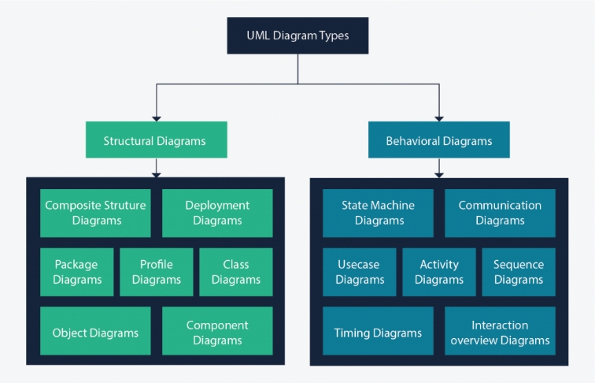
Figure 4: UML 2.5 diagrams overview (source: https://creately.com/blog/diagrams/uml-diagram-types-examples/ )
- STUDY OF UNIFIED PROCESSES
- Unified Process (UP)
A Unified Process is a generic software development method. Generic means that it is necessary to adapt UP to the context of the project, team, domain and/or organization.
- Iteration is distinct sequence of activities with a basic plan and evaluation criterion that produces an internal or external output.
- An increment is the difference between two released products at the end of two iterations. Each iteration that the group is capable of integrating the technical environment.
- Centered on architecture the different models derived during the establishment of system must be reliable and coherent.
- Driven by use case and requirements enables the clear definition of a user’ needs and priorities respectively thereby minimizing the risk of project failure.
- Two Track Unified Process (2TUP)
2TUP is a unified process, which is built on UML and has as objective to bring solution to constraints of functional and technical changes imposed on information systems by strengthening controls on development capacities.
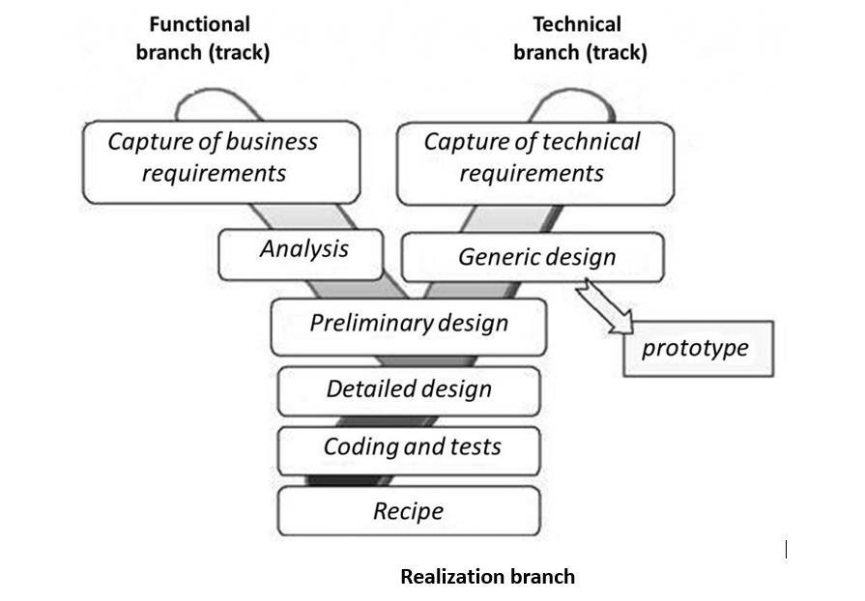
Figure 5:2TUP diagram (Source:https://www.mysciencework.com/omniscience/pervasive-mobile-healthcare-system-basedon
a. The left branch (functional branch)
It captures the functional needs of a system.
b. The right branch (Technical branch)
The technical branch enumerates the technical needs and proposes a generic design validated by a prototype.
c. The middle branch (Realization or Implementation branch)
In this branch, we study the preliminary conception, detailed conception, and documentation of the system.

The realization branch supports the following:
- Preliminary conception: This is the most sensitive step of 2TUP as it is the confluence of the functional and technical branch. It is completed when the deployment model, the operating model, the logical model, interphases and the software configuration model are defined. We have the following diagrams:
- Detailed conception: This is the detailed design of each feature of the system.
- Coding and testing: This is the phase where we program the designed and coded features.
- The recipe: Also known as, the deliverables is the validation phase of the functions of
the developed system.

CHARACTERISTICS OF 2TUP
The two-track unified process was built to be used with the Unified Modeling
Language to become a method and has the following characteristics:
- It is user oriented: 2TUP is built from user’s expectation.
- It is component oriented: it offers flexibility to the model by supporting the re-use
of components.
- It is an iterative process: processes are being done in iterations and each iteration
shows a precise level of abstraction.
- It is an incremental process: allowing a better functional and technical risk management and thus constituting the deadlines and the cost control.

CHOICE OF THE ANALYSIS METHOD
On very important notice is that UML is not a method but a modelling language. There exist several Unified Processes but our modelling approach will be the 2TUP (Two-track unified process) which we will use in the course of our project.
Table 10 : Comparison between MERISE and UML
MERISE | UML
It is based on procedural approach | Based on object approach
Suitable for relational databases design and implementation | Suitable for object-oriented design and implementation
It stands for Méthode d'Étude et de Réalisation Informatique pour les Systèmes d'Entreprises | Unified Modeling Language
MERISE is a systemic method of analysis and design of information systems. That is, it uses a systems approach. | UML is however not a method but rather an  object modeling language to which it is necessary to associate an approach to make  it a method. This is the case with the 2TUP  method: RUP and XP.
Merise is a method of analysis | UML is modeling language
Emphasizes data analysis and modelling using data flow diagrams (DFD), entity-relationship diagrams (ERD), and data dictionaries. | Emphasizes system behaviour and structure using 14 diagram types, such as use case diagrams, class diagrams, and activity diagrams

JUSTIFICATION OF THE ANALYSIS METHOD
The reason why we chose UML modelling language and the software development process 2TUP instead of many others that exist, include:
- UML is the current standard for programming in an object-oriented language. For this reason, it is widely understood and well known making it easy for a new programmer to join the project and be productive from the very first day.
- UML diagrams allow teams to virtualize how a project is or will be working, and they can be used in any field, not just software engineering. The diagrams will allow teams to virtualize together how a system or a process will work or did work. It can provide new ideas for how teams have to collaborate to achieve the goal of the workflow process.
- 2TUP is centered around the creation and maintenance of a model, rather than the production of mountain documents.
- 2TUP is user oriented as it permits the development of software that responds to the needs of the users through the study of the user needs.
- 2TUP is iterative and incremental, hence it enables the project team to produce refined amelioration if necessary and easily integrate it in the already existing system.
- 2TUP by permitting the project team identify and test the key functionalities of the system limits the risk related to building the system.

MODELING OF THE PROPOSED SOLUTION
- USE CASE DIAGRAM
- Definition
Use case diagram shows the functionalities of a system, their interdependencies and how they relate with actors of the system. A use case is a specification of behavior. The main objectives of the use case diagram are:
- Provide a high-level view of the system.
- Identify the functions of the system.
Use case diagrams are completed with a textual description of each use case that is intended to define the use case in details.

- Formalism
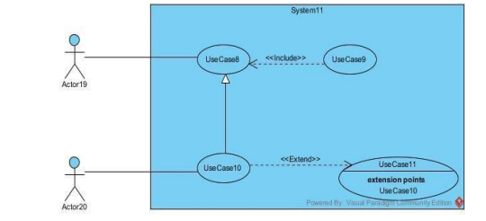
Figure 6: Use case formalism

- Components of use case diagram
Table 11 : Component of use case diagram Component of use case diagram
Element | Notation | Description
Actors |  | Represents an entity that directly interacts with the system. The actor is what performs the different possible actions of the system
Use case | 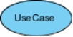 | A use case represents a functionality of the system. An actor can perform an action.
Association | 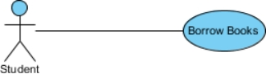 | It indicates that an actor takes part in a use Case.
Include | 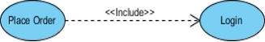 | An inclusion denotes that an included action must be performed before the including action can be performed.
Extend | 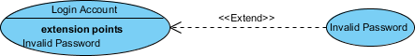 | An extension denotes that an extending action may be performed while an extended action is being performed.
Generalization |  | This shows that an actor or a use case is a kind of other abstract or concrete actors, which can be defined and later specialized using generalization relationship.
System |  | It is a container of use cases which interact with external actors

- Actors of our system
Table 12 : Actors of our system
Actor | Role
Client | Login/Register, activate GPS, search for a drug, view nearby pharmacies and availability, select pharmacy, place order, upload prescription, choose pickup/delivery, make payment, track order, receive medicine, use AI symptom checker, view health tips
Delivery Agent | Receives assignment, picks medicine, delivers it, updates delivery status
Pharmacist / Cashier | Receives order, checks actual stock, confirms/rejects order, verifies prescription
Pharmacy Admin | Registers and manages pharmacy information, manages pharmacy stock, adds/updates/removes medicines, manages pharmacy delivery agents, manages delivery schedule/window
Super Admin | Manages user accounts, manages pharmacies, monitors orders and payments, manages disputes, views platform analytics, manages health tips
Gemmi AI | Provides an advisory symptom checker, analyzes user-provided symptoms and provides general health guidance; does not provide a medical diagnosis
Geolocation API | Location, nearby pharmacy information, route, ETA/travel time
Payment API | Processes Mobile Money payment

  - General Use Case Diagram
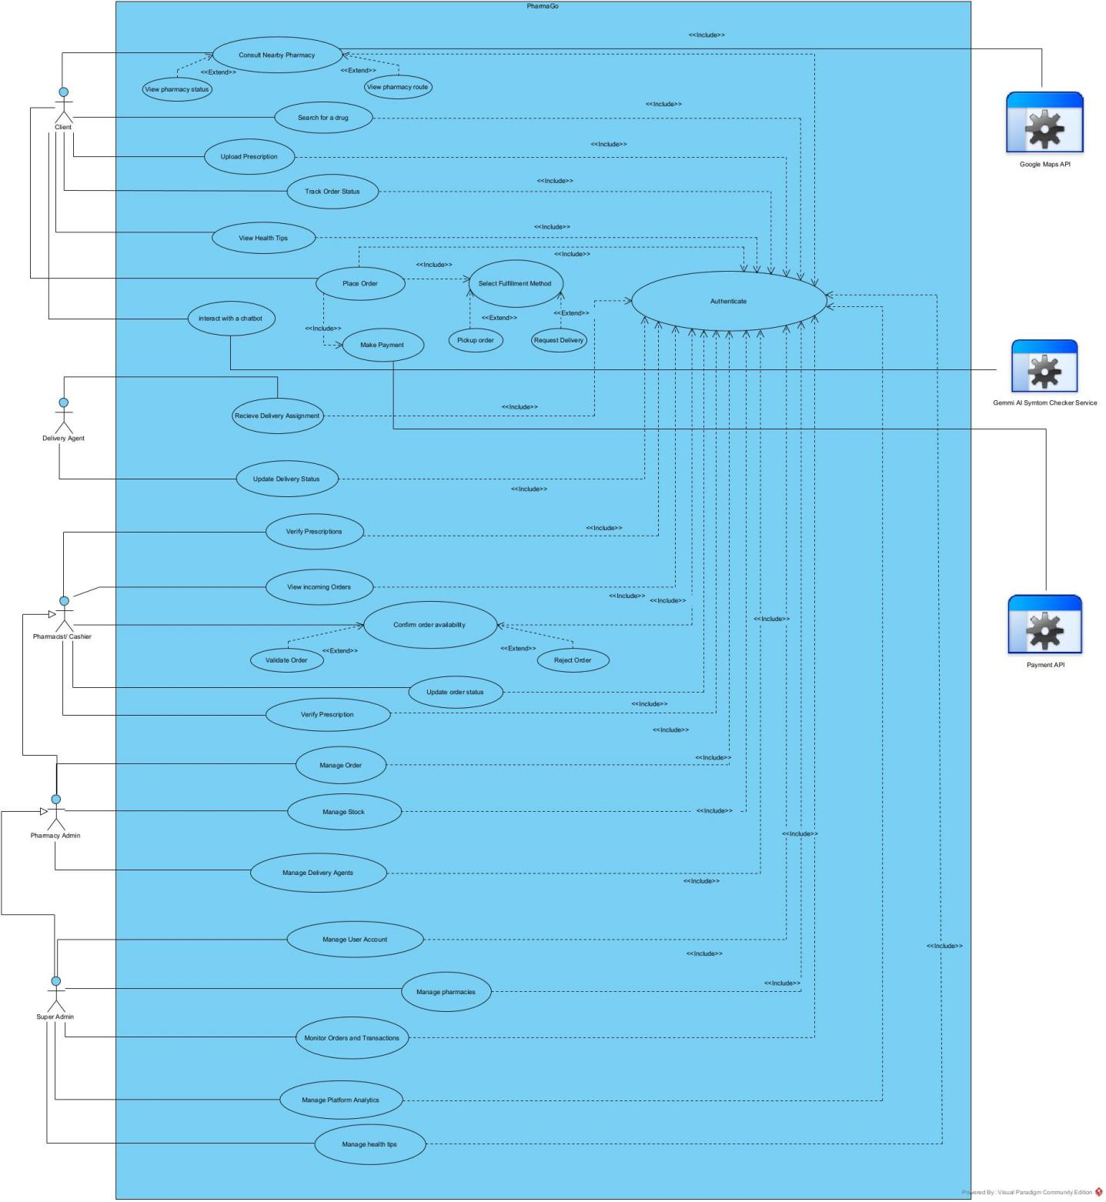
Figure 7: General use case diagram
- Textual Description
UML allows the execution of a use case to be described in a textual way, in a form called nominal scenario. A nominal scenario describes in more detail the execution of a use case by an actor until it is successfully completed.

- Formalism
A textual description of a use case is represented in the following form
Table 13 : Textual description formalism
NAME OF THE USE CASE
Summary | Aim of the use case
Actors | Users
Pre-condition | Set of actions that must be completed before the launching of the use case
Trigger | The event that causes the use case to be initiated
Nominal scenario | It corresponds to a normal development of a use case
Alternative scenario | These are variants of the nominal scenario.
Post condition | Set of mechanism that can lead to the end of the use case

1. Create Account
Table 14 : Textual description of Create account
Field | Description
Name of the Use Case | Create Account
Summary | Allows a new client to register in the system to gain access to waste management services.
Actors | Client (new user)
Pre-condition | User has internet access and a device.
Trigger | User selects Create Account on the app/website.
Nominal Scenario | 1. User clicks Create Account.  2. System displays registration form.  3. User enters name, email/phone, and password.  4. System validates input.  5. Account created and saved.  6. Confirmation displayed.
Alternative Scenario | - Input invalid (weak password, duplicate email/phone) → error displayed.  - Validates and stores new user record; sends confirmation.
System Response | Client account Created
Post-condition of success | Client has a valid account and can log in.
Post-condition of failure | Client not log in and error message

2. Search drug and pharmacy
Table 15 : Textual description of search drug and pharmacy
Field | Description
Name of the Use Case | Search Drug and Pharmacy
Summary | Allows a client to search for a medicine and identify nearby pharmacies where the medicine is listed as available.
Actors | Client, Geolacation API
Pre-condition | Client has a valid PharmaGo account, is logged in, has an internet connection, and has activated GPS/location services.
Trigger | Client enters the name of a medicine in the search bar and submits the search.
Nominal Scenario | 1. Client opens the drug search feature.  2. System requests the client's location.  3. Client activates GPS and grants location permission.  4. Client enters the name of the desired medicine.  5. System validates the search request.  6. System searches the database for pharmacies listing the requested medicine in their stock.  7. System identifies nearby pharmacies using the client's location.  8. System displays the matching pharmacies and the medicine's listed availability.  9. Client selects a pharmacy to view its details.  10. Client can proceed to Place Order.
Alternative Scenario | 1. GPS is disabled → System asks the client to activate GPS.  2. Location permission is denied → System informs the client that location access is required.  3. Medicine is not found → System displays Medicine not found.  4. No nearby pharmacy lists the medicine → System displays No nearby pharmacy found with this medicine.  5. Search information is invalid → System asks the client to enter a valid medicine name.  6. Database or Geolocation API unavailable → System displays an error and asks the client to try again.
System Response | Displays nearby pharmacies where the requested medicine is listed as available, together with relevant pharmacy information and location.
Post-condition of success | Client identifies a suitable pharmacy and can proceed to place an order for the medicine.
Post-condition of failure | No matching pharmacy is found, and the client receives an appropriate notification.

3. Place Order
Table 16 : Textual description of Make Payment
Field | Description
Name of the Use Case | Place Order
Summary | Allows a client to place an order for a selected medicine from a nearby pharmacy through the PharmaGo platform.
Actors | Client, Pharmacist/Cashier
Pre-condition | Client has a valid PharmaGo account, is logged in, and has selected a pharmacy and medicine.
Trigger | Client selects a medicine and clicks Place Order.
Nominal Scenario | 1. Client selects a pharmacy and medicine.  2. Client clicks Place Order.  3. System displays the order details.  4. Client confirms the order request.  5. System creates and saves the order.  6. System sends the order to the Pharmacist/Cashier for verification.  7. Pharmacist/Cashier checks the actual stock.  8. Pharmacist/Cashier confirms the order.  9. System updates the order status to Confirmed.  10. Client receives the order confirmation.
Alternative Scenario | 1. Required medicine is not actually available → Pharmacist/Cashier rejects the order.  2. Prescription is required but not provided → System requests prescription upload.  3. Order information is incomplete or invalid → System displays an error and asks the client to correct it.
System Response | Order is created, sent for pharmacy verification, and, if accepted, marked as Confirmed.
Post-condition of success | Client has a confirmed order and can proceed to choose pickup or delivery.
Post-condition of failure | Order is not confirmed and the client receives an appropriate notification explaining the reason.

- Activity Diagram
An activity diagram provides a behavior view of the system by describing the sequence of
action in a process or a particular activity. The activity diagram makes it possible to emphasis the processing and to graphically formalize the sequence of action carried out in the use case.
- Formalism
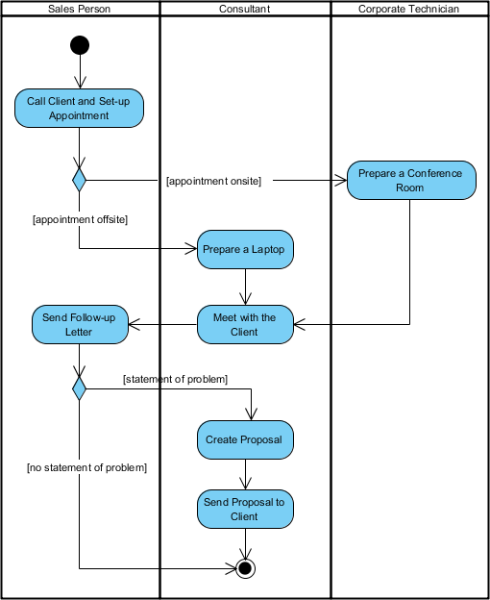
Figure 8: Activity diagram formalism

- Component of an Activity diagram
Table 17 : Component of an Activity diagram
Element | Notation | Description
Activity | 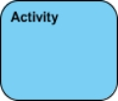 | Is used to represent a set of actions
Action | 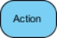 | A task to be performed
Activity Edge |  | An activity edge in a UML activity diagram is a directed connection between two activity nodes.
Initial node |  | Portrays the beginning of a set of actions or activities
Activity Final Node |  | Stop all control flows and object flows in an activity (or action)
Object node | 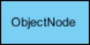 | Represent an object that is connected to a set of Object Flows
Decision node | 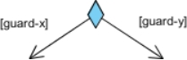 | Represent a test condition to ensure that the control flow or object flow only goes down one path
Merge node | 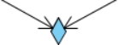 | Bring back together different decision paths that were created using a decision-node.
Fork node | 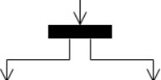 | Split behavior into a set of parallel or concurrent flows of activities (or actions)
Join node | 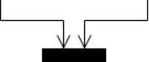 | Bring back together a set of parallel or concurrent flows of activities (or actions).
Swimlane and Partition | 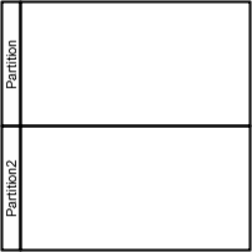 | A way to group activities performed by the same actor on an activity diagram or to group activities in a single thread
- Activity diagram of Authenticate
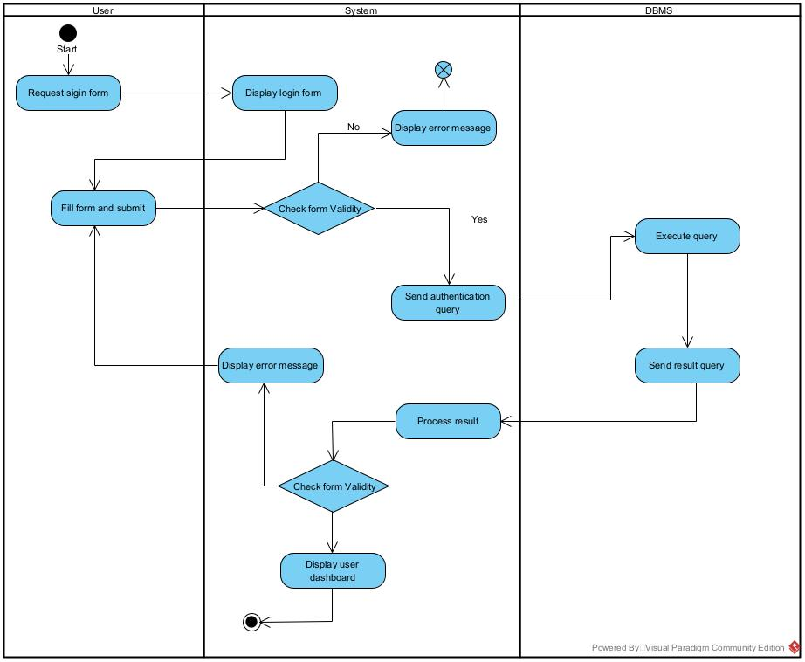
Figure 9: Authenticate activity diagram
- Activity diagram of Account Creation
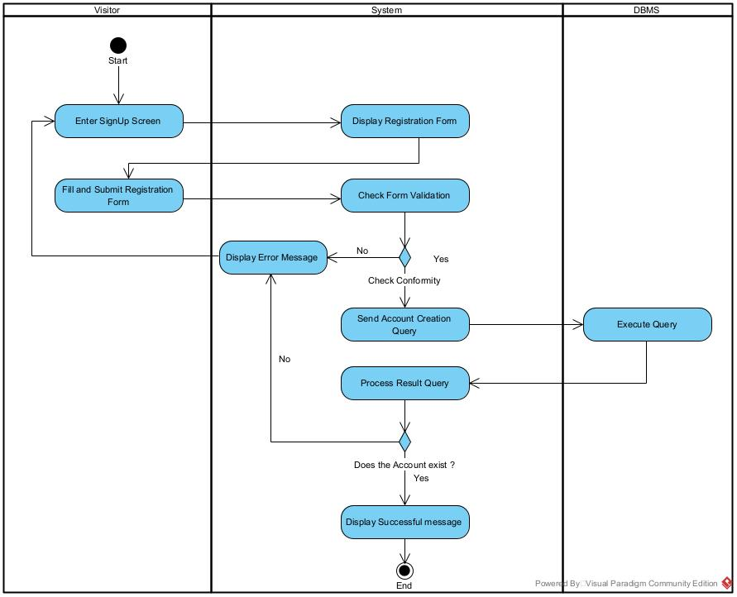
Figure 10: Create account activity diagram
- Activity diagram of Search Drug and Pharmacy
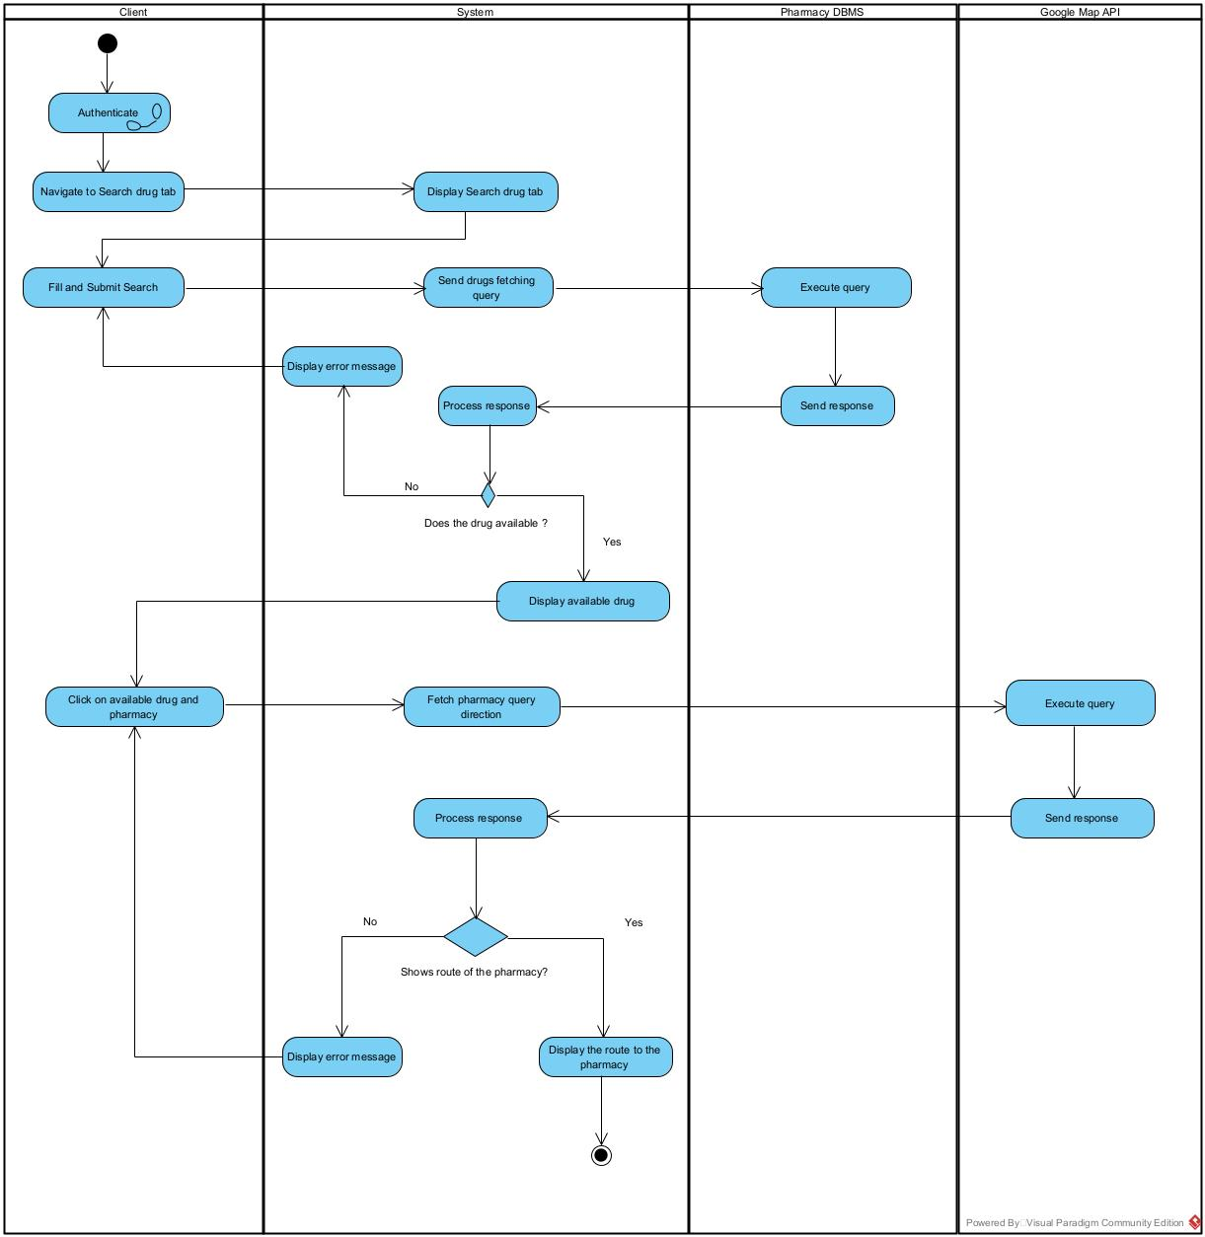
Figure 11: Search drug and Pharmacy activity diagram
- Activity diagram of Place Order
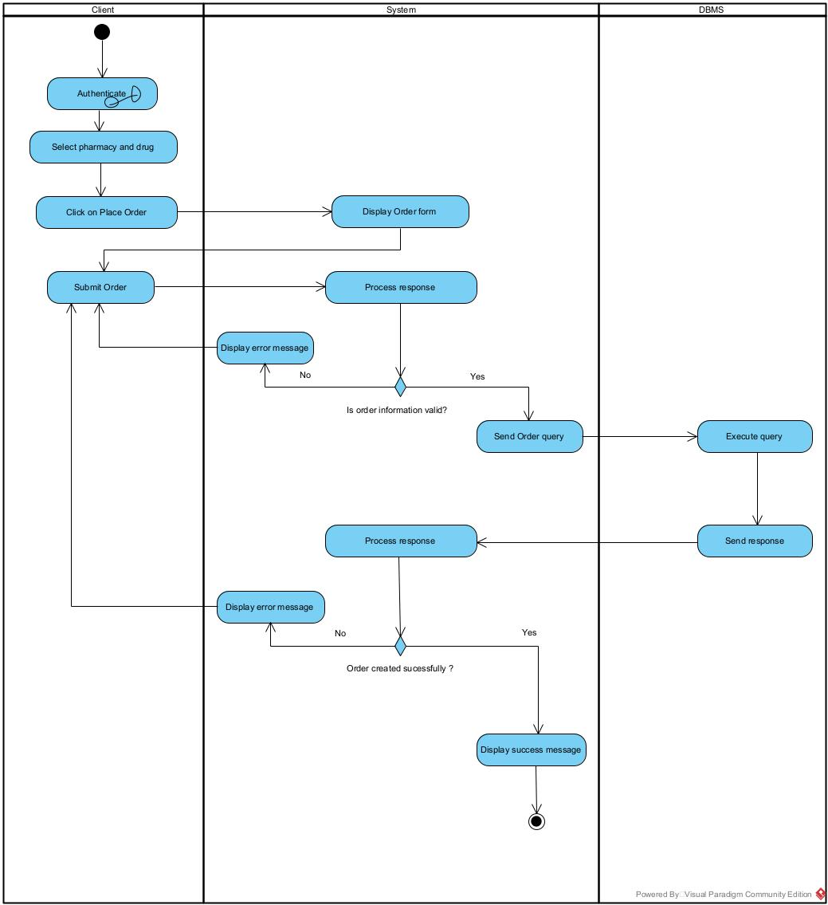
Figure 12: Place Order activity diagram

- SEQUENCE DIAGRAM
- Definition
A Sequence diagram describes interactions among classes in terms of an exchange of messages over time. They are also called event diagrams. A Sequence diagram is a good way to visualize and validate various runtime scenarios. These can help to predict how a system will behave and to discover responsibilities a class may need to have in the process of modelling a new system.
- Formalism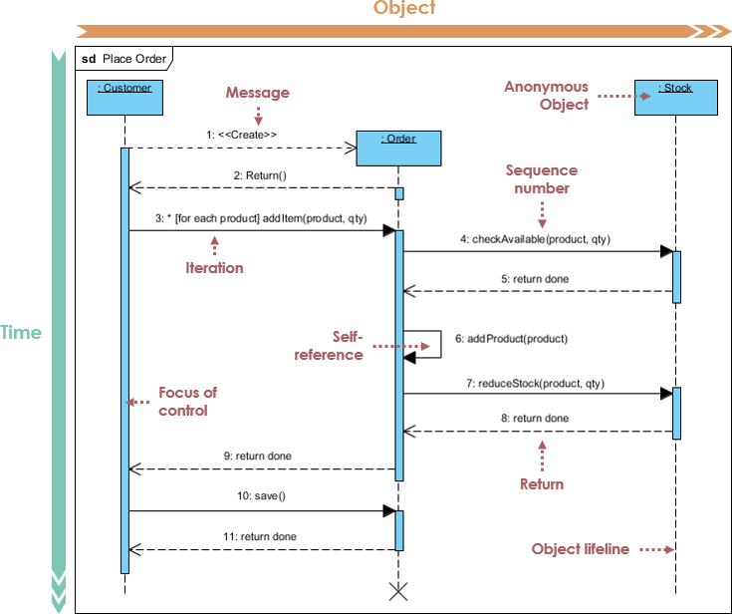
Figure 13: Sequence diagram formalism

- Component of sequence diagram
Table 18 : Component of sequence diagram
Element | Notation | Description
Lifelines | 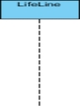 | They represent rows or objects instances that participate in the sequence being modelled.
Asynchronous Message | 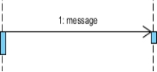 | It is a message that receives an indirect response.
Synchronous Message |  | It is a message that sends and want response before it continues a process
Self-Message | 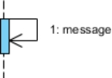 | Self-message is a kind of message that represents the invocation of message of the same lifeline.
Return Message | 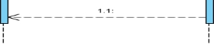 | It represents the response of a message.
Actor |  | They send and receive message.
Combined Interaction Fragment | 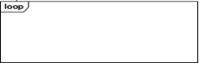 | An articulation of interaction diagram, defined by an operator and operands.
Object | 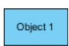 | They send and receive messages

- Sequence diagram of Authenticate
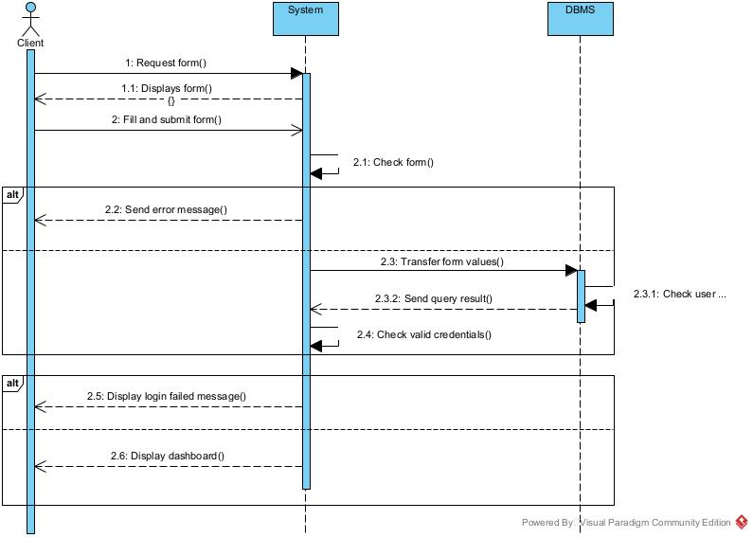
Figure 14: Sequence diagram of Authenticate

- Sequence diagram of Search Drug and Pharmacy
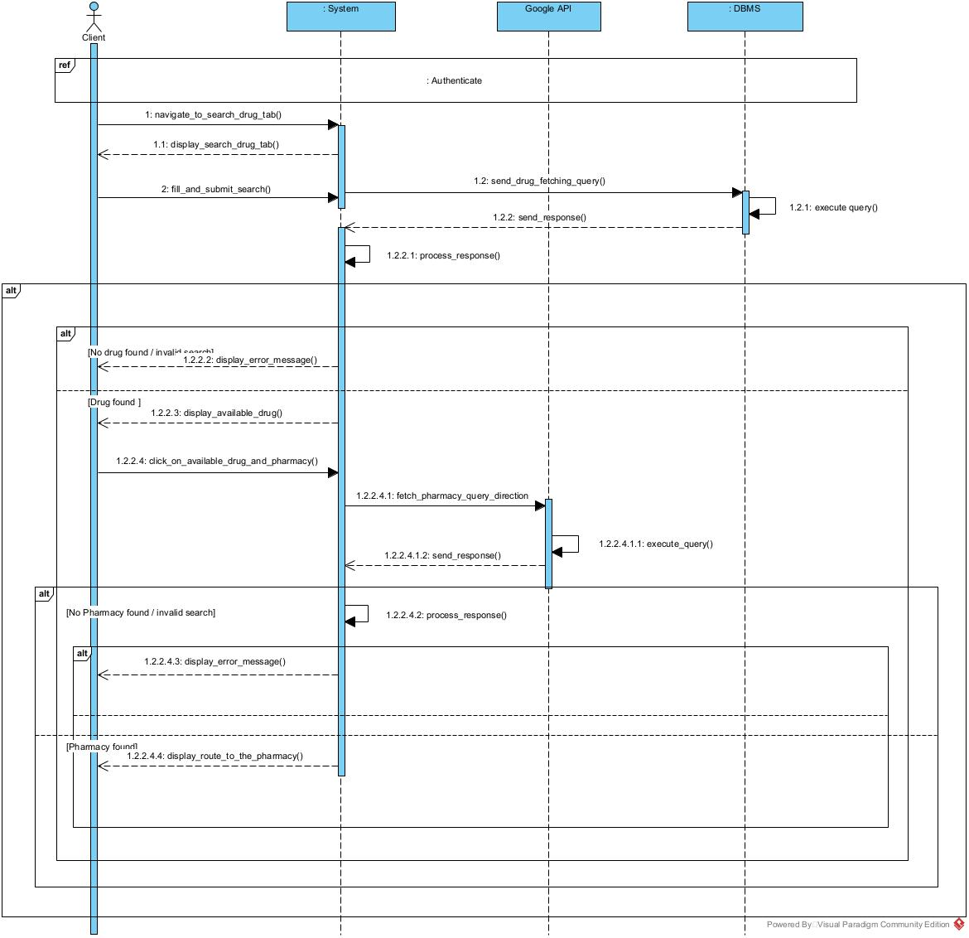
Figure 15: Search drug and Pharmacy
- Sequence diagram of Place Order
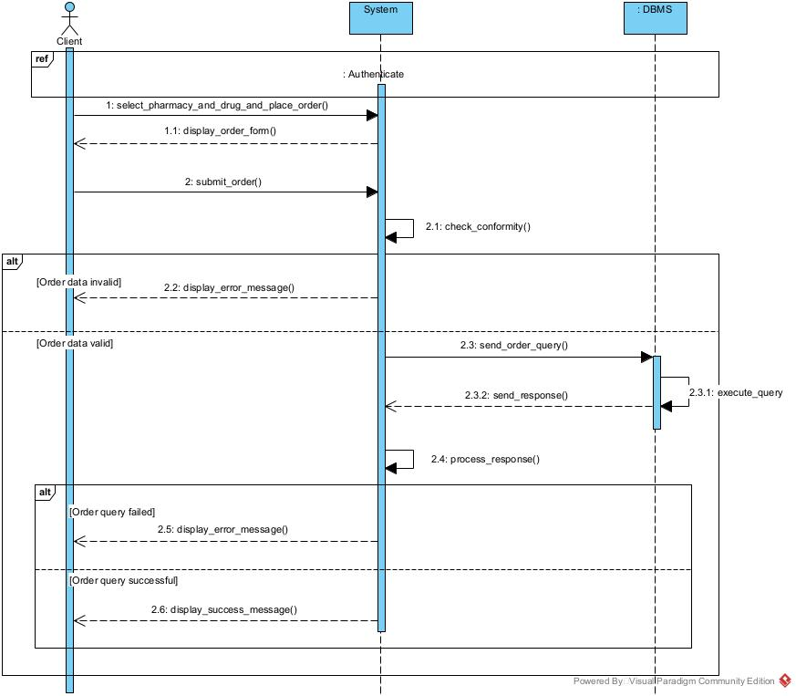
Figure 16: Place Order sequence diagram

- COMMUNICATION DIAGRAM
- Definition
Communication Diagrams model the interactions between objects in a sequence. They describe both the static structure and the dynamic behavior of a system. It is a simplified version of a Collaboration Diagram introduced in UML 2.0. A communication diagram is more focused on showing the collaboration of objects rather than the time sequence.
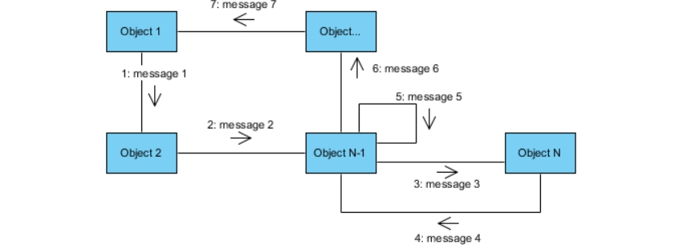
- Formalism
Figure 17: Communication diagram formalism

- Components of a communication diagram
Table 19 : Component of a communication diagram
Element | Notation | Description
Message | 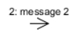 | Designs a particular communication between lifelines.
Actors |  | A role play by an entity that interacts with the subjects
Link |  | It initiates an association it connects two objects together for them to communicate.
Object |  | An actor represents an individual participant in the interaction conversation

- Communication diagram of Authenticate
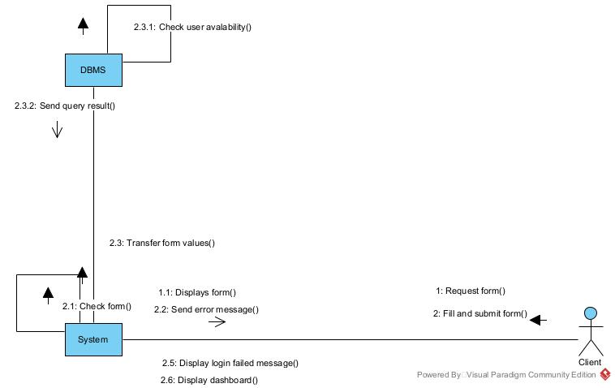
Figure 18: Authenticate Communication diagram

- Communication diagram of Search Drug and Pharmacy

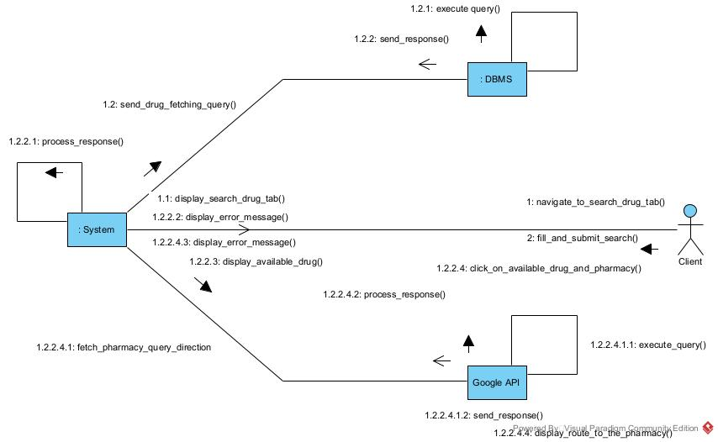
Figure 19: Search drug and Pharmacy communication diagram
- Communication diagram of Place Order
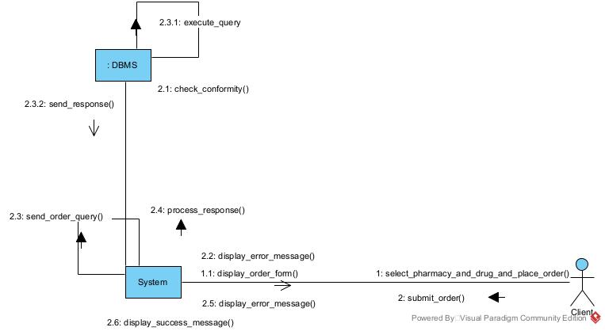
Figure 20: Place Order Communication diagram

- STATE MACHINE DIAGRAM
- Definition
A class diagram is a static diagram. It represents the static view of an application. class diagram is not only used for visualizing, describing and documenting different aspect of the system but also for constructing executable code of the software application. Class diagram describes the attribute and operation of a class and constraints imposed on the system. Its purpose is to model the static view of an application.
- Formalism
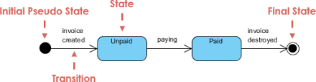
Figure 21: Formalism of a state machine diagram

- Component of a state machine diagram
Table 20 : Component of state machine diagram
Element | Notation | Description
State | 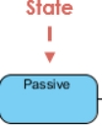 | Models a situation during which a certain invariant condition holds.
First (Initial State) |  | It represents a default vertex, that is, a source for a single transaction to the default or composite state.
Final state |  | A state specifying that the enclosing region is complete
Transition | 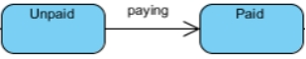 | A direction relation between a source and a target vertex.
Choice pseudo state |  | A diamond symbol that indicates a dynamic condition with branched potential results
Terminate |  | Implies that the execution of a state by means of it context is terminated.
Diagram overview |  | A placeholder for the linked states in a state machine diagram.

- State machine diagram of Account
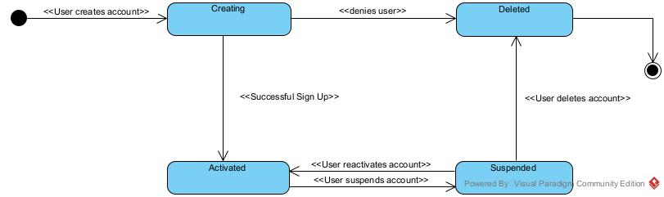
Figure 22: Account Creation State machine diagram
- State machine diagram of Order
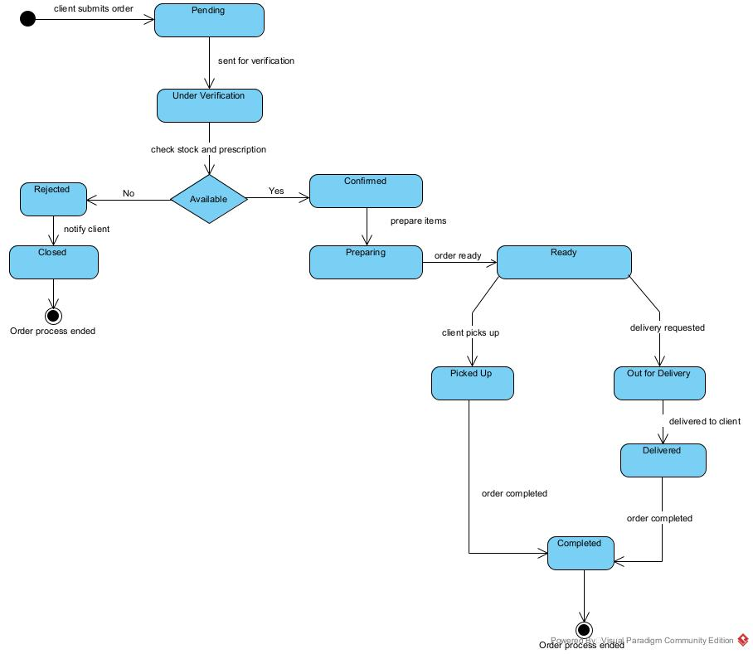
Figure 23: Order State machine diagram

CONCLUSION
During the analysis phase, we selected a software development process and modelling language. Next, we elaborated on the functional requirements of our system. We reviewed the use case diagram, which outlines the relationship between actors and the actions they can perform in the system, as well as the communication diagram that illustrates the architecture of the system based on object-oriented programming. We also analysed the sequence diagram, which delineates the flow of messages between elements in the system. Lastly, we reviewed the activity diagram, which displays the workflow of our system. We will proceed to the conception phase, during which we shall highlight the Technical branch of our system, accompanied by relevant diagrams.

FILE 4: CONCEPTION PHASE

Preamble
The conception phase is the part of the document that shows the link between the analysis and the realization phases. It is a continuation of the analysis phase, which represents the technical aspects used in modelling our system.

Content Overview

INTRODUCTION
- TECHNICAL BRANCH
- GENERIC DESIGN
- CAPTURE OF TECHNINCAL NEEDS
- RELATED UML DIAGRAMS
- CLASS DIAGRAM
- PACKAGE DIAGRAM
CONCLUSION

INTRODUCTION
The concept stage will outline the precise requirements, characteristics and activities needed to fulfil the operational needs of the suggested system, as defined during the analysis stage. The objective during this phase is to recognize and examine key components (either hardware or software), configuration (network capacity), processes and procedures, which are indispensable for the system to achieve its desired outcomes. We will scrutinize several diagrams such as the class diagram, state machine diagram and package diagram.

TECHNICAL BRANCH

CAPTURE OF TECHNICAL NEEDS

Physical Architecture
The physical architecture describes how the principal components of PharmaGo are deployed and how they communicate at the infrastructure level.
The system can be represented through several interacting nodes:
- Client devices, which access the PharmaGo mobile application or web portal.
- Flutter mobile application, which provides the client interface and communicates with the backend API.
- React/Vite web portal, which provides interfaces for Pharmacy Admin, Pharmacist/Cashier, and SuperAdmin.
- Express.js backend, which provides the REST API and the main business services.
- PostgreSQL database, which stores application data, including users, pharmacies, drugs, stocks, orders, prescriptions, payments, and delivery information.
- Supabase Storage, which stores uploaded prescription images.
- External services, including Google Maps API for geolocation and routing, Gemini API for the AI assistant, and the Mobile Money payment gateway.

a. Presentation Tier
The presentation tier consists of client devices running the PharmaGo Flutter mobile application and web browsers accessing the React/Vite web portal. The Flutter application is primarily used by clients to search for medicines, locate nearby pharmacies, place orders, choose pickup or delivery, make payments, and track orders. The React/Vite web portal is used by Pharmacy Admin, Pharmacist/Cashier, and SuperAdmin to manage pharmacies, stock, orders, prescriptions, deliveries, and platform operations. Both presentation interfaces communicate with the Express.js backend through HTTP/REST requests.
b. Logic Tier
The logic tier consists of the Node.js and Express.js backend. In the local configuration, the backend exposes its REST API through port 5000.
It provides the main business services, including:
- authentication and authorization;
- pharmacy and stock management;
- drug and pharmacy search;
- order processing and confirmation;
- prescription management;
- payment processing;
- pickup and delivery management;
- order tracking;
- notification management;
- AI assistant integration.
The backend communicates with external services through HTTPS, normally using port 443.
These external services include the Google Maps API, Gemini API, and Mobile Money payment gateway.
c. Data Tier
The data tier is implemented using PostgreSQL, which stores PharmaGo's persistent application data, including:
- user accounts and roles;
- pharmacy information;
- drugs and stock records;
- orders and order items;
- prescriptions;
- payments;
- delivery information;
- health tips;
- order and transaction statuses.
Prisma ORM is used by the Express.js backend to access and manage the PostgreSQL database.The database connection uses the standard PostgreSQL service port 5432.Prescription images and other required files are stored separately using Supabase Storage, accessed through HTTPS.

d. External Services Tier
The external services tier contains services provided by third-party platforms that extend PharmaGo's functionality.
- Google Maps API provides pharmacy location, nearby pharmacy search, route calculation, and estimated travel information.
- Gemini API provides the AI functionality used by the advisory symptom-checking assistant.
- Mobile Money Gateway handles electronic payments through supported Mobile Money services such as MTN MoMo and Orange Money.
Communication between the Express.js backend and these external services is performed through HTTPS, normally over port 443.
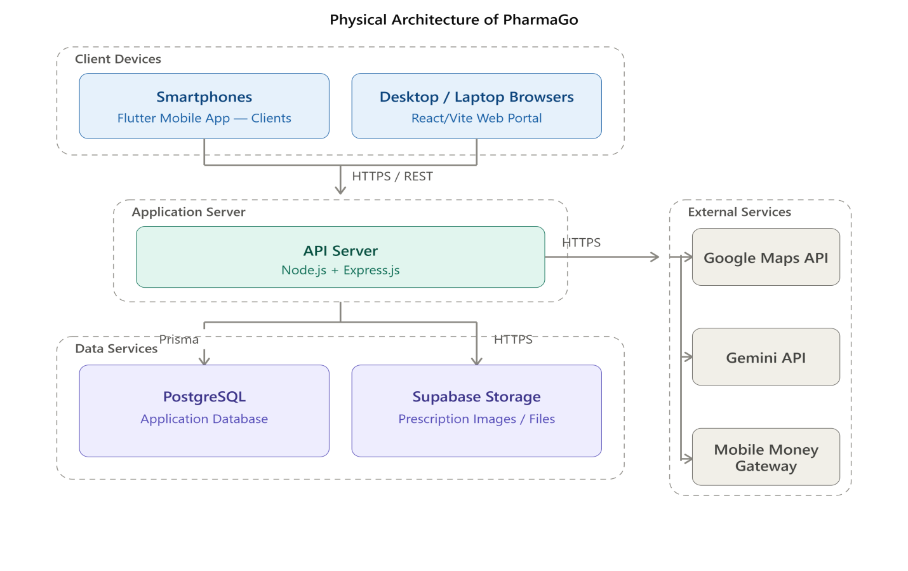
Figure 25 : The Physical Architecture Source

Logical Architecture
PharmaGo follows a client-server layered architecture in which the presentation, application logic, data management, security, and external services are organized into distinct but interconnected layers.
The Flutter mobile application provides the main interface for clients, while the React/Vite web portal supports Pharmacy Admin, Pharmacist/Cashier, and SuperAdmin operations. Both interfaces communicate with the Node.js/Express.js backend through REST APIs.
The backend contains the main business logic for authentication, pharmacy and stock management, drug search, orders, prescriptions, payments, delivery, tracking, and notifications. It communicates with the PostgreSQL database through Prisma ORM for persistent data storage and integrates external services such as Google Maps API, Gemini API, Mobile Money Gateway, and Supabase Storage when required.

a. Presentation Layer
The presentation layer consists of the Flutter mobile application and the React/Vite web portal.
The Flutter application allows clients to authenticate, search for medicines and nearby pharmacies, place orders, upload prescriptions, choose pickup or delivery, make payments, and track orders.
The React/Vite portal provides interfaces for Pharmacy Admin, Pharmacist/Cashier, and SuperAdmin to manage pharmacies, stocks, orders, prescriptions, deliveries, and platform activities.
Riverpod is used for state management in the Flutter application, while GoRouter manages navigation.

b. REST API Layer
The REST API layer provides communication between the presentation interfaces and the Express.js backend. The backend exposes REST endpoints for functionalities such as:
- Authentication
- Pharmacy management
- Stock and drug management
- Drug and pharmacy search
- Orders
- Prescriptions
- Payments
- Delivery and tracking
- Notifications
- Administration

c. Controller/API Layer
The controller layer receives requests from the mobile application and web portal and forwards them to the appropriate business services.
It handles requests related to authentication, pharmacies, stocks, drugs, orders, prescriptions, payments, deliveries, tracking, and administration.

d. Business Logic Layer
The business logic layer contains the core rules and processes of PharmaGo.
It manages:
- User authentication and authorization
- Pharmacy and stock management
- Drug availability search
- Order processing and confirmation
- Prescription verification
- Pickup and delivery management
- Payment processing
- Delivery tracking
- Notifications
- AI-assisted services
This layer also ensures that a pharmacist or cashier confirms actual medicine availability before an order is considered confirmed.

e. Data Access Layer
The data access layer provides communication between the Express.js backend and PostgreSQL.
Prisma ORM is used to perform database operations and manage the application's data models.
It provides structured access to information related to users, pharmacies, drugs, stocks, orders, prescriptions, payments, deliveries, and other application entities.

f. Database Layer
The database layer is implemented using PostgreSQL.
It stores the persistent information required by PharmaGo, including:
- Users and roles
- Pharmacies
- Drugs
- Stock records
- Orders and order items
- Prescriptions
- Payments
- Deliveries
- Health tips
- Notifications and statuses

g. Security Layer
Security is implemented as a transversal concern across the application.
PharmaGo uses authentication and authorization mechanisms to protect user accounts and platform resources. Role-Based Access Control (RBAC) ensures that each user accesses only the functionalities corresponding to their role.
Additional security mechanisms include password protection, input validation, protected API endpoints, secure communication through HTTPS, and controlled access to sensitive information such as prescriptions and payment data.

h. Notification and Tracking Services
PharmaGo provides notification and order-status mechanisms to keep users informed about important events such as order confirmation, rejection, payment status, and delivery progress.
The tracking functionality uses location and route information provided through the Google Maps API to support delivery-related information such as route and estimated travel time.

i. AI Integration
PharmaGo integrates the Gemini API to provide an AI-assisted symptom-checking function. The backend communicates with Gemini through HTTPS and processes the returned information before presenting it to the client. The AI functionality is advisory and non-diagnostic and encourages the user to consult a qualified healthcare professional when necessary.

j. Geolocation and Maps Integration
The platform integrates the Google Maps API to support:
- Pharmacy location
- Nearby pharmacy search
- Pharmacy location display
- Route calculation
- Estimated travel information
The backend communicates with Google Maps through secure HTTPS requests.

k. Payment Integration
PharmaGo integrates a Mobile Money payment gateway to support electronic payments. The backend communicates with the payment gateway through HTTPS, while the gateway handles supported Mobile Money services such as MTN MoMo and Orange Money, depending on the configured provider.

Advantages of the Architecture
- Separation of responsibilities: Each layer has a specific role, making the system easier to understand and manage.
- Maintainability: Changes to one layer can be made with limited impact on other parts of the application.
- Extensibility: New services, payment providers, or external APIs can be integrated without restructuring the entire system.
- Security: Authentication, authorization, validation, and protected communication help secure the platform and its sensitive information.
- Scalability: The separation between the client interfaces, backend services, database, and external integrations provides a foundation for future expansion.
- Integration capability: PharmaGo can communicate with external services such as Google Maps, Gemini, Mobile Money gateways, and Supabase Storage while keeping these integrations separate from the core business logic.
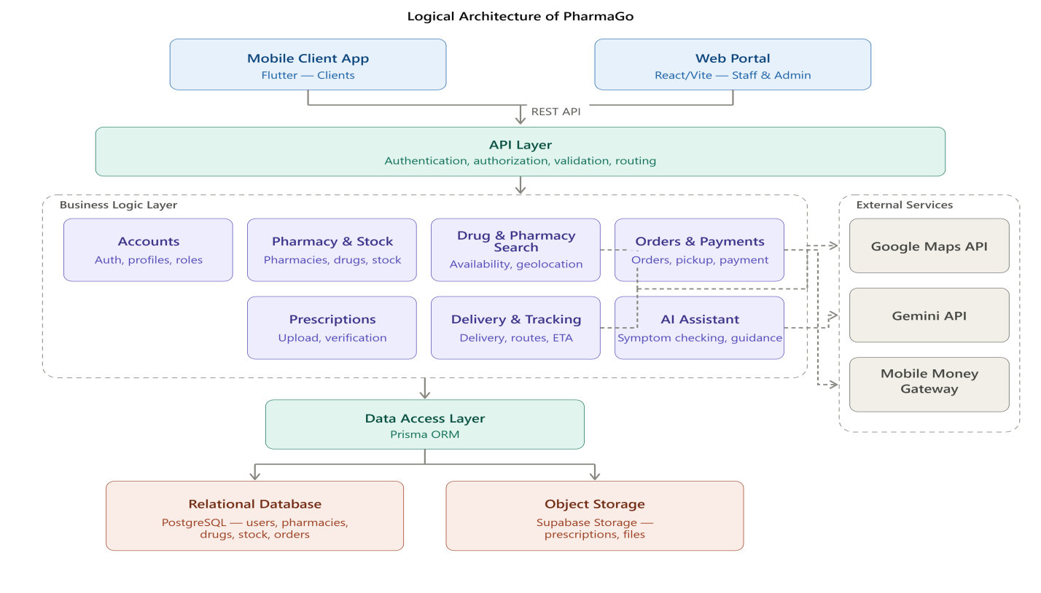
Figure 26 : The Logical architecture

- RELATED UML DIAGRAMS
- CLASS DIAGRAM
- Definition
A class diagram is a static diagram. It represents the static view of an application. class diagram is not only used for visualizing, describing and documenting different aspect of the system but also for constructing executable code of the software application. Class diagram describes the attribute and operation of a class and constraints imposed on the system. Its purpose is to model the static view of an application.
- Formalism
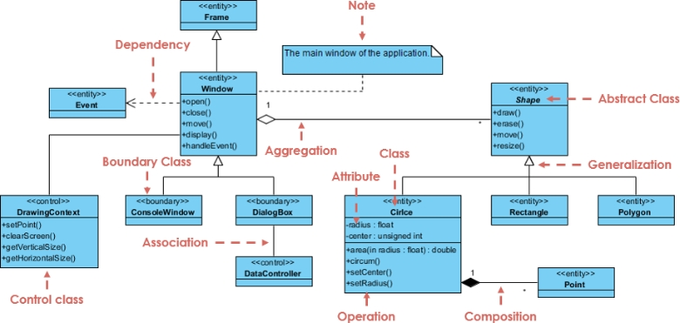
Figure 27 : Class diagram formalism

- Component of a Class diagram
Table 21 : Components of class diagram
Element | Notation | Description
Class | 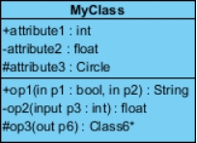 | A class is an element that defines the attributes and behaviors that an object can generate
Generalization | 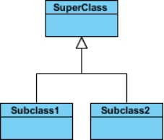 | it a relationship between a whole thing (called superclass) and a more specific thing (called subclass)
Association | 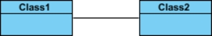 | It is a general type of relationship between elements, it may include cardinality, roles etc.
Aggregation | 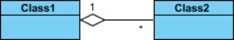 | If the parent of the aggregate is deleted, the children are not deleted.
Composition | 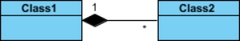 | If a parent of a composite is deleted all its parts are deleted with it.
Dependency | 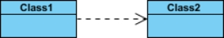 | It existed between two classes, if one changes it may cause the change in the order, but the other way around.

- Representation of the Class Diagram

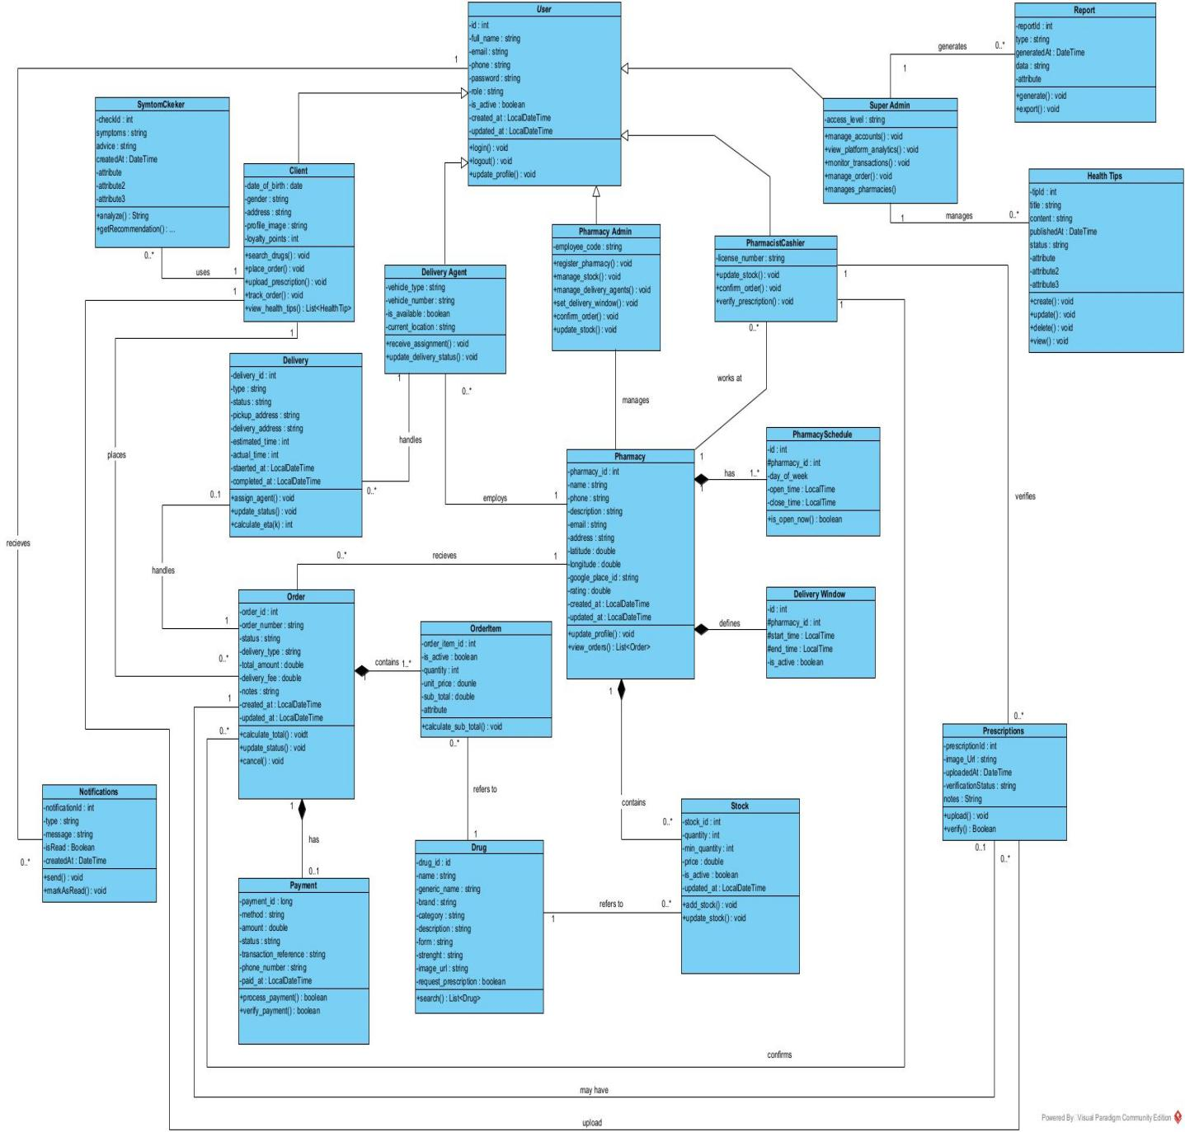
Figure 28 : Class diagram

- PACKAGE DIAGRAM
- Definition
This is a structural diagram used to show the organization and arrangement of various model elements in the form of packages.
- Formalism
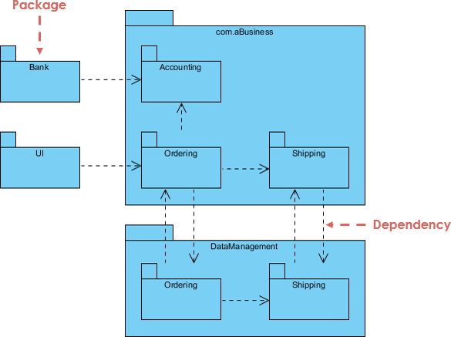
Figure 29 : Package diagram formalism

- Component of package diagram
Table 22 : Component of package diagram
Element | Notation | Description
Package | 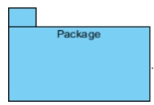 | A package is a namespace use to group related elements; it is a mechanism used to group elements into a better structure in a system.
Package import | 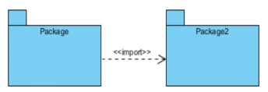 | A relationship Indicate that, functionality has been imported from one package to another.
Package access | 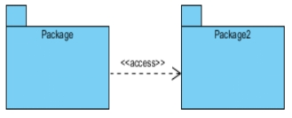 | A relationship Indicates that one package requires assistance from the function of another package.
Package merge | 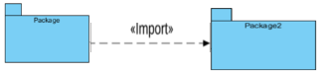 | A relationship shows that, the functionality of two packages are combines to a single function.

- Representation of the Package Diagram
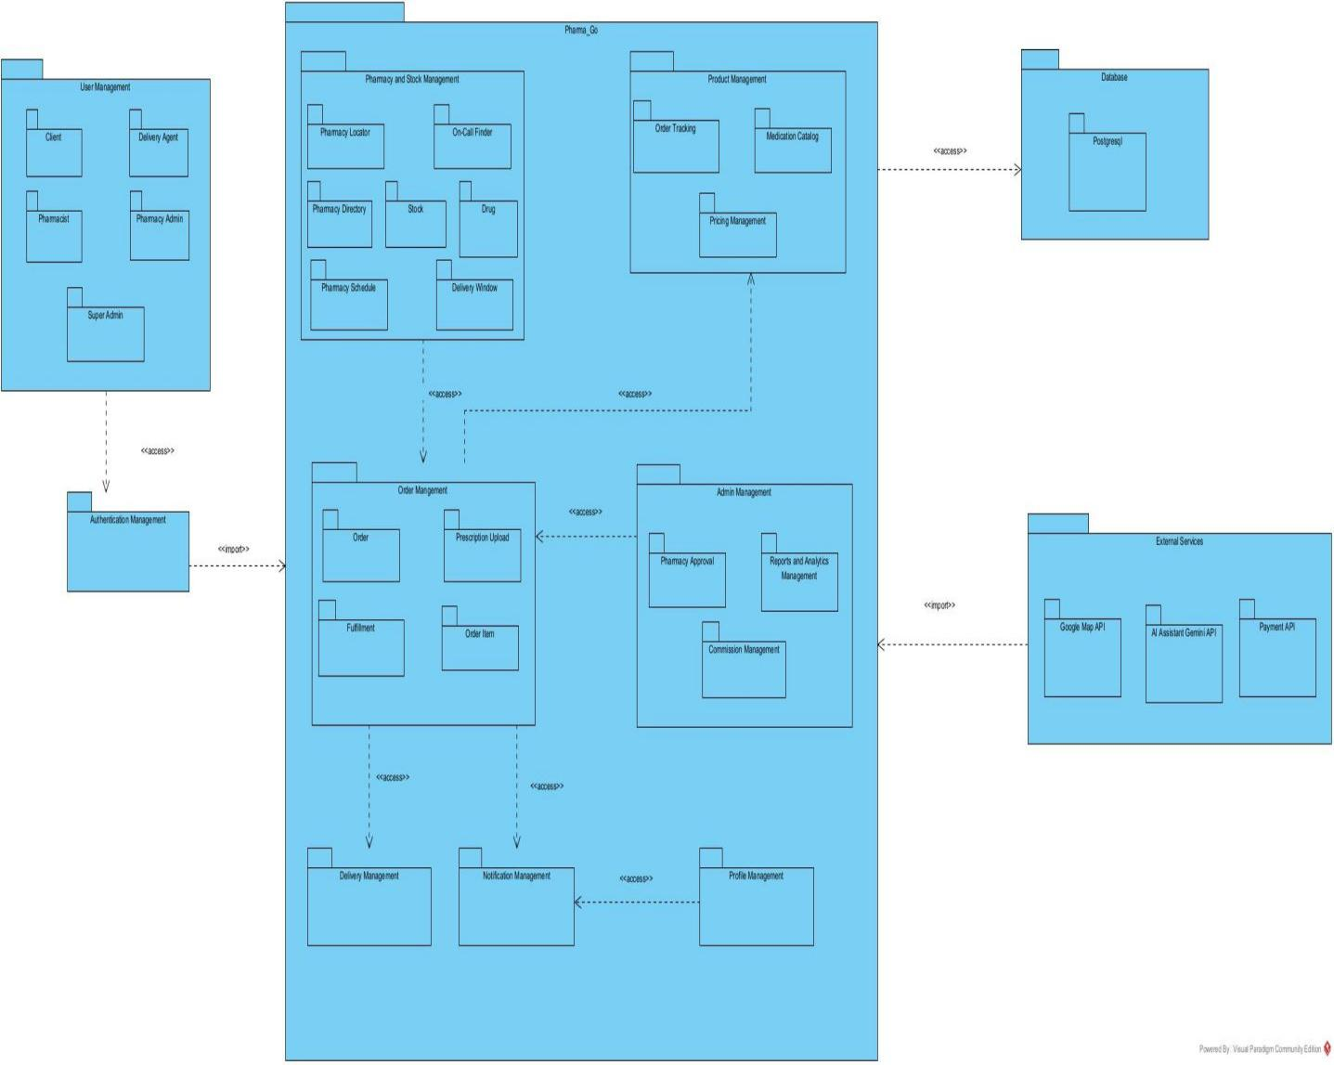
Figure 30 : Package diagram

CONCLUSION
We presented the structure of our system and its integration into the existing technical architectures. In the initial stage, we aimed to investigate various aspects of our system. Primary actions included assessing the technical limitations, identifying the system's components with their classification and deployment onto relevant deployment targets. We then concluded this phase by evaluating the interactions between different components and participants of our system. Moving forward, our report will now progress to the implementation phase, which will entail concentrating on executing our system-related elements.

FILE 5: CONCEPTION PHASE

Preamble
In this phase we will go straightforward in the implementation of our solution, we will base ourselves on the analysis and conception phases, also present the component and deployment diagrams.

Content Overview

INTRODUCTION
I. COMPONENT DIAGRAM
II. DEPLOYMENT DIAGRAM
III.TECHNICAL CHOICES
CONCLUSION

INTRODUCTION
Here in the realization phase, we will concentrate on building or implementing our solution, we will review diagrams concerning the physical aspects of the system, such as libraries, documents and the physical topology of the system components when the software is deployed. Based on the various analyses and concepts developed earlier, this phase is as critical as the previous ones. It focuses on the physical topology of deployed components, the tools used to realize the application, the chosen programming language, and the overall architecture as it is implemented in code and infrastructure.

COMPONENT DIAGRAM
- Definition
It is mainly use to describe the dependencies between various software component such as the dependency between executable file and source files. It represent the internal structure of your software (Software component). You must represent the different classes, libraries, modules, or files. It represents the technical architecture of your system.
- Formalism
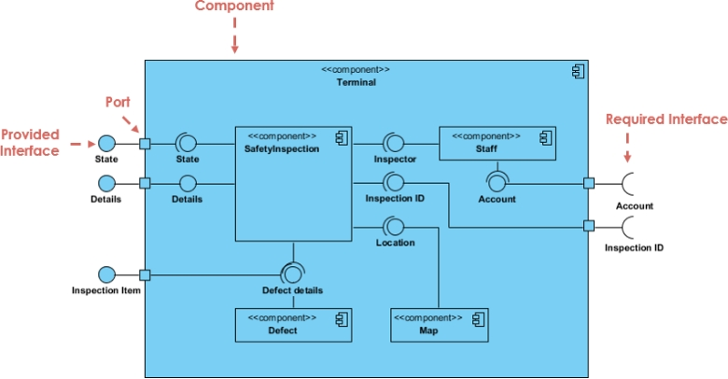
Figure 31 : Component diagram formalism

- Component of Component diagram
Table 23 : Component of component diagram
Element | Notation | Description
Dependency |  | A dependency is a relationship that signifies that a single or a set of model elements requires other model elements for their specification or implementation.
Port | 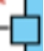 | A port is often used to help expose required and provided interfaces of a component.
Interface | 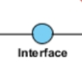 | It is a point of interaction between a component and its environment or other components. It specifies the services that a component provides or requires from other components
Component | 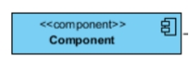 | It represents a self-contained and replaceable unit that interacts with other components via provided and required interfaces

- Representation of the Component diagram
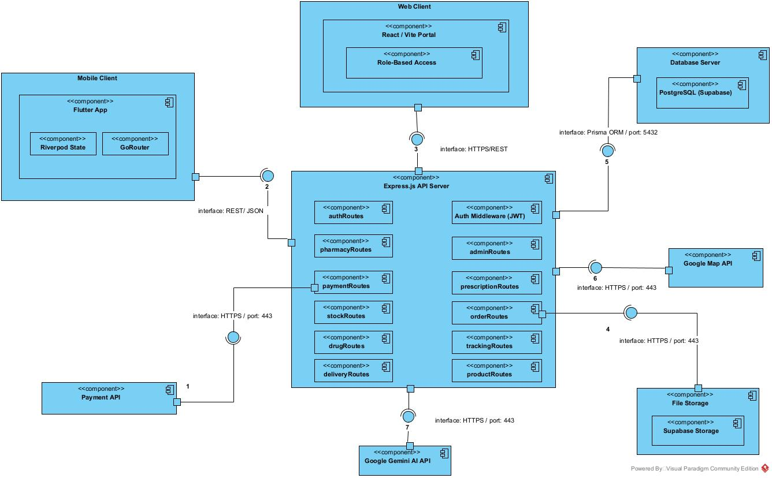
Figure 32 : Component diagram

DEPLOYMENT DIAGRAM
- Definition
A deployment diagram is a visual representation of the physical architecture of a computer system. The diagram represents the physical disposition of materials resources that constitute the system and shows the component repartition (software elements) that are executed inside these materials. It shows how the different hardware and software components of a system are connected and deployed on different nodes.
- Formalism
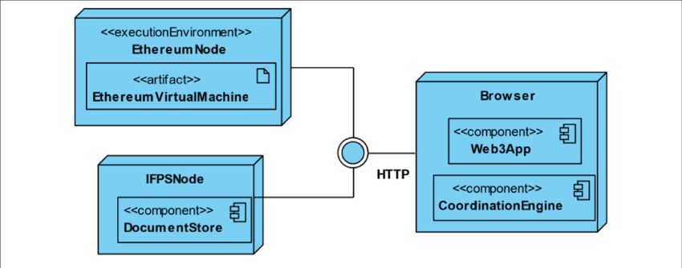
Figure 33 : Formalism of Deployment diagram

- Component of Deployment diagram
Table 24 : Component of deployment diagram
Element | Notation | Description
Node | 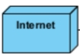 | A hardware or software object, shown by a three-dimensional box
Artifact | 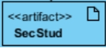 | An artifact is a major product, which is produced or used during the development of a software. E.g. diagrams, data models, setup scripts
Component | 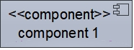 | It represents a modular part of a system that encapsulates its content and whose manifestation is replaceable within it environment.
Association |  | An association helps to connect two nodes together which permits them to communicate together

- Deployment diagram
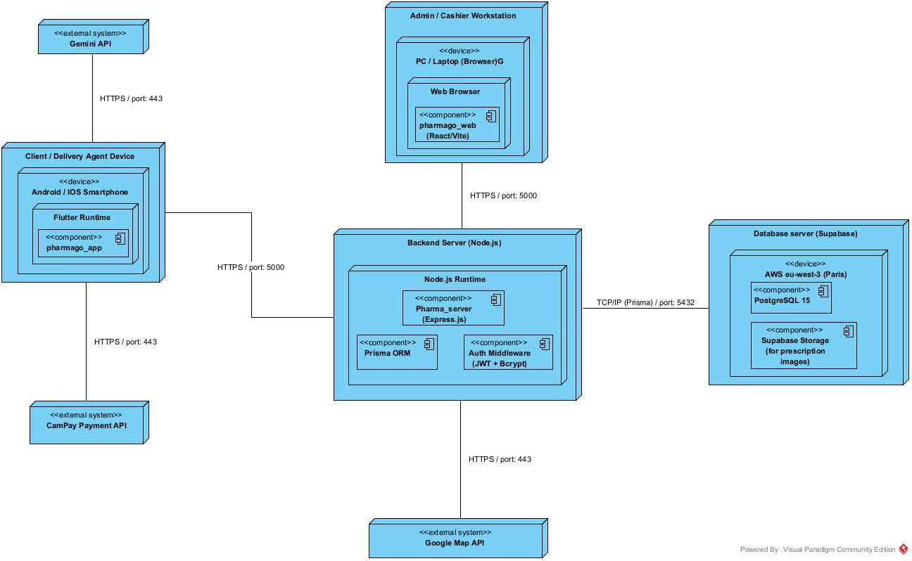
Figure 34 : deployment diagram

TECHNICAL CHOICES
To design and implement PharmaGo and meet the needs of its end-users, several technologies and tools were selected based on the requirements of the platform.
Each of these technologies and tools is presented below:
  - Flutter
Flutter is an open-source UI framework developed by Google for building applications from a single codebase. It uses the Dart programming language.

Figure 35: Flutter logo
  - React and Vite:
React is an open-source JavaScript library used to build interactive user interfaces, particularly for web applications. Vite is a modern development tool that provides a fast development environment and optimized build process for web applications.

Figure 36 : React and Vite logo

  - Node.js and Express.js:
Node.js is an open-source, cross-platform JavaScript runtime environment that enables JavaScript to be executed on the server side. It is well suited for developing scalable web services and APIs. Express.js is a lightweight web framework for Node.js that simplifies the development of HTTP APIs and server-side applications.

Figure 37: Node.js and Express.js
  - PostgreSQL
PostgreSQL is an open-source, object-relational database management system known for its reliability, data integrity, and support for complex queries and relationships.

Figure 38: PostgreSQL logo

e. Prisma ORM
Prisma is a modern Object-Relational Mapping (ORM) tool for Node.js and TypeScript applications. It provides a structured way for the application to interact with relational databases while simplifying database queries and data management.

Figure 39 : Prisma ORM logo

F. Supabase Storage
Supabase Storage is a cloud-based storage service designed for storing and managing files.
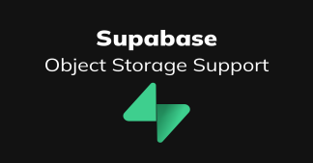
Figure 40 : Supabase Storege logo
  - Gantt Project;
Project Gant is a widely used project management tool for planning and tracking project tasks over a given period.

Figure 41 : Gantt Project logo
  - Visual paradigm:
Visual Paradigm Community Edition is a UML software that supports all UML diagram.

Figure 42 : Visual Paradigm logo
  - Postman
Postman is a popular API development tool that facilitates the creation, testing of APIs. It is widely used by developers, testers to simplify the process of working with HTTP APIs.

Figure 43 : Postman logo

CONCLUSION
During our realization phase, we successfully developed and implemented our application. To achieve this, we utilized our analysis and conception phase. We also created deployment and component diagrams that illustrate the modules, files, and assets, as well as how different elements interact with each other within our system. Our next step is to move onto the functionalities testing phase, where we will assess the efficacy of the various modules present in our app for different users.

FILE 6: TEST OF FUNCTIONALITIES

Preamble
In this report, we will explore the different aspects of the test of functionalities and its significance in the software development life cycle.

Content Overview
INTRODUCTION
- TEST OF FUNCTIONALITIES
- TEST SHOWCASES
CONCLUSION

INTRODUCTION
The test of functionalities plays a crucial role in ensuring the quality and reliability of software systems. By thoroughly examining each functionality and validating its behavior, developers can identify potential issues early in the development process. This helps in reducing the overall cost and effort required for bug fixing and maintenance.

TEST OF FUNCTIONALITIES
- What is Unit Testing
Unit testing involves testing the smallest parts of an application, such as functions or methods, independently from the rest of the application. Unit testing ensures that each component of the application works independently and correctly. It helps catch bugs early in the development process and guarantees that future changes do not break existing functionality.
- Testing Strategy
We implemented unit testing to isolate and test individual parts of the app, specifically the API endpoints and backend services. Unit testing provides fast feedback on code quality and behavior.
- Tools Used
- Jest: testing framework used for running unit tests.
- Supertest: For HTTP testing for Express APIs requests.
- PostgreSQL: Used as the application's relational database, with test data and controlled database operations used during testing.
- Key Functionalities Tested

a. User Registration
- Tests verify that a user can successfully create an account using valid information.
- Invalid or incomplete information is tested to ensure that the system rejects inappropriate registration requests.
- Duplicate account information is checked to ensure that the system prevents unauthorized duplicate registrations.

b. User Authentication
- Tests verify that users can successfully log in using valid credentials.
- Invalid credentials, such as an incorrect password, are tested to ensure that authentication fails appropriately.
- Successful authentication is verified through the generation of the appropriate authentication token.

c. Drug and Pharmacy Search
- Tests verify that a client can search for a requested medicine.
- The system checks pharmacies that list the requested medicine in their stock.
- Search results are verified to ensure that relevant pharmacy and drug information is returned.
- Cases where the medicine is unavailable or no matching pharmacy is found are also considered.

d. Place Order
- Tests verify that a client can place an order after selecting a pharmacy and a requested medicine.
- The required quantity and selected pharmacy are validated.
- The system verifies that the order is correctly created and stored.
- Pickup and delivery options are checked as part of the order process.

e. Order Confirmation
- Tests verify that a Pharmacist/Cashier can review an incoming order.
- The pharmacist confirms or rejects the order based on the actual availability of the medicine.
- The order status is updated accordingly and the client receives the appropriate response.

TEST SHOWCASES
- Passing Unit Tests
- User Registration: Demonstrates successful user registration with valid data and shows successful login and token generation when valid credentials are provided.
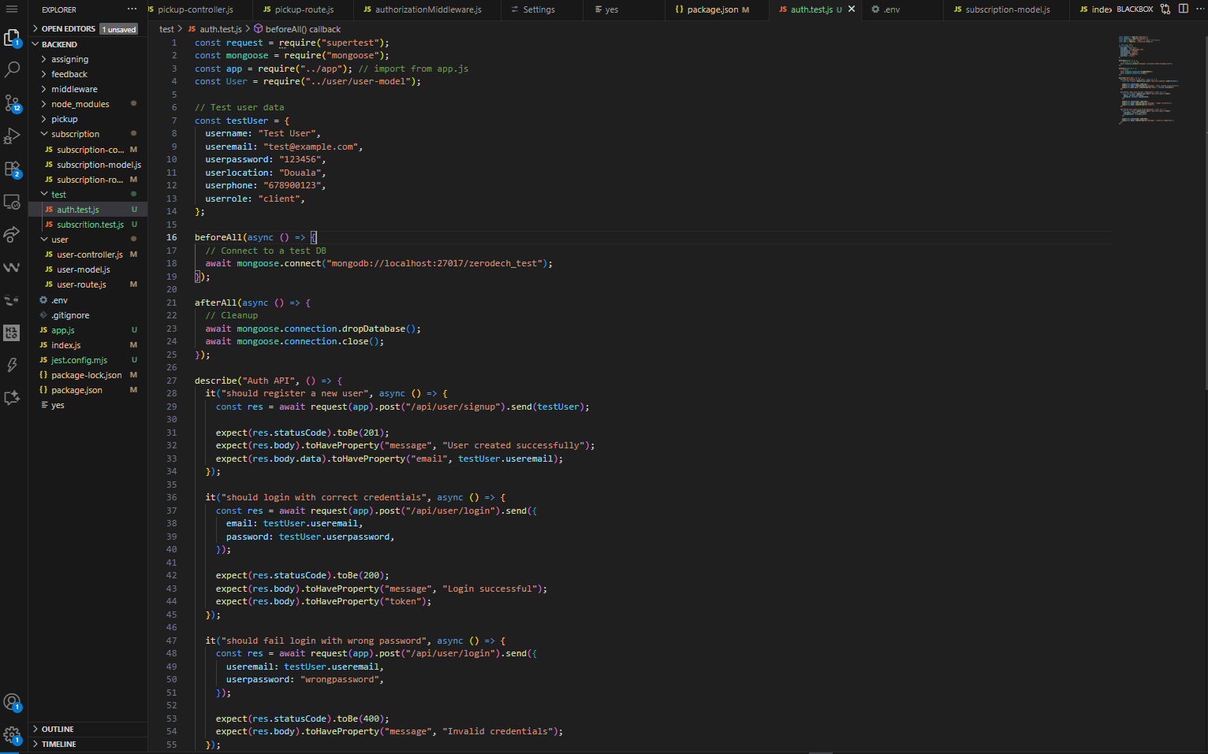
Figure 44 : User registration and login code test

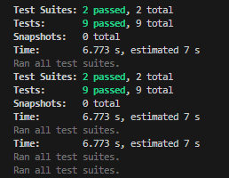
Figure 45 : User registration and login test
- Client — Place an Order: Demonstrates the process of placing a drug order after selecting a pharmacy with the requested medicine. The client selects the available drug and pharmacy, specifies the required quantity, chooses pickup or delivery, and submits the order
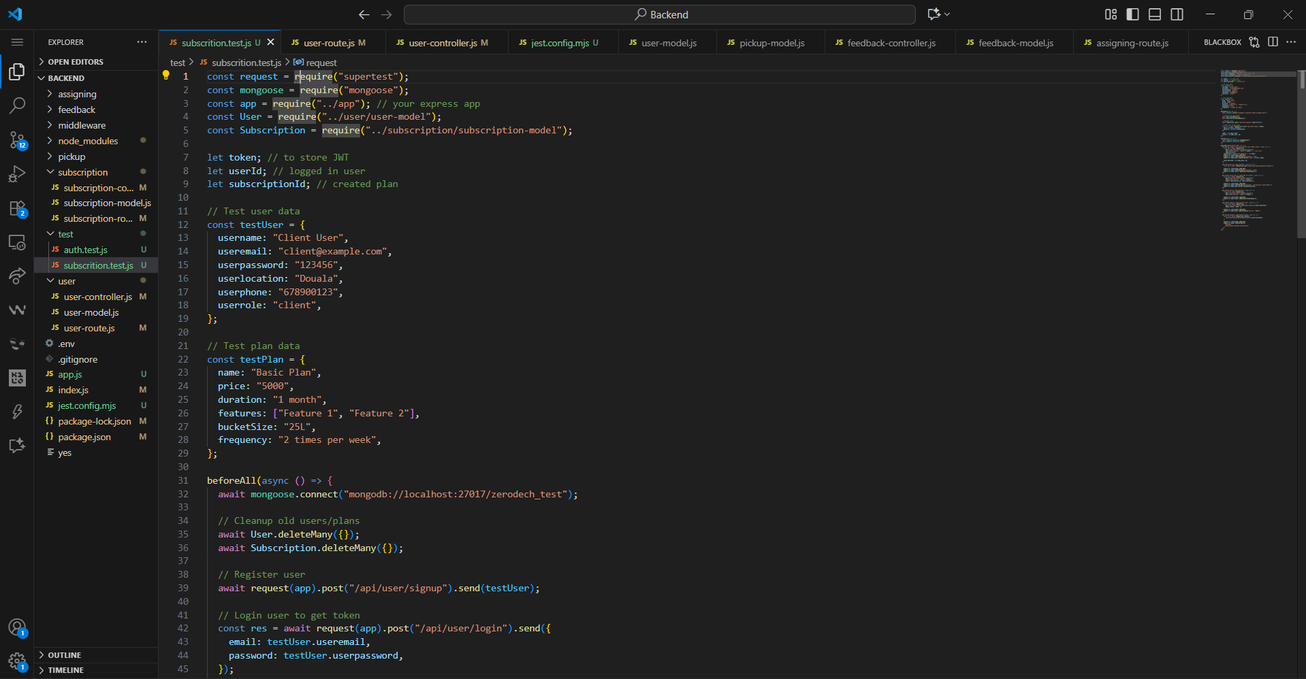
Figure 46 : Client Place Order test
Figure 47 : Client Place Order test

CONCLUSION
Testing is an integral part of the software development life cycle and is performed to verify the correctness, reliability, and robustness of the implemented functionality. The functionality and testing phase is therefore a critical stage in software development where the implemented features are validated, and any issues are identified and resolved.

FILE 7: INSTALLATION GUIDE AND USER GUIDE

Preamble
A user guide explains how to use a software application in a language that a non-technical person can understand. Thus, it enables the user to easily use the application to familiarize themselves with the software and discover all its functionalities.

Content Overview
INTRODUCTION
- DESCRIPTION OF THE APPLICATION
- USER MANUAL
CONCLUSION

INTRODUCTION
The user manual is the document established after the realization of an application, software, or platform. It informs on the question "how to use the software, the application, or the platform that you have in front of you? ". It is therefore crucial for us to offer the various users of our platform a guide allowing them to easily perform various operations on our platform.

I. DESCRIPTION OF THE APPLICATION
PharmaGo is a pharmacy stock management and drug ordering platform designed to improve access to medicines in Cameroon. The application allows clients to search for medicines, identify nearby pharmacies with the requested drug in stock, place orders, and choose between pharmacy pickup and delivery.
The system is organized around three main operational layers:

1. Clients
Clients use the PharmaGo mobile application to:
- Create an account and authenticate.
- Search for available drugs.
- Locate nearby pharmacies using geolocation.
- View pharmacy information and opening/closed status.
- View routes and estimated travel time.
- Place an order.
- Upload a prescription when required.
- Track the status of an order.
- Choose pickup or delivery.
- Make payment using Mobile Money or Cash on Delivery.
- Consult health tips.
- Use the advisory AI symptom checker.
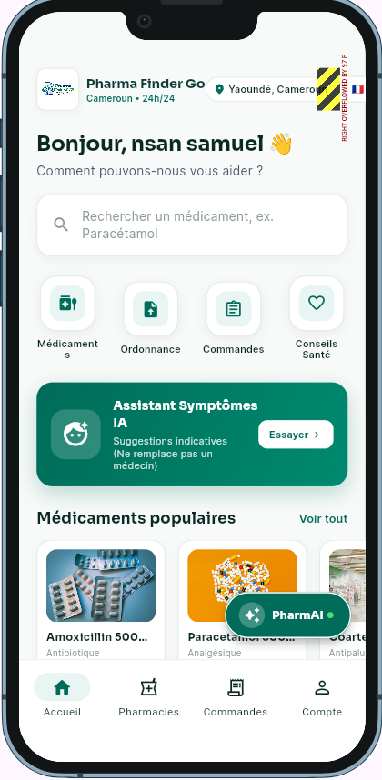
Figure 48: Client Portal

2. Pharmacy Staff
Pharmacy staff use the web dashboard to manage pharmacy operations.
- Pharmacy Admin can:
- Register and manage the pharmacy.
- Add, update and remove drugs from stock.
- Manage drug quantities.
- Manage pharmacy delivery agents.
- Manage pharmacy orders.
- Configure pharmacy information and delivery schedules.
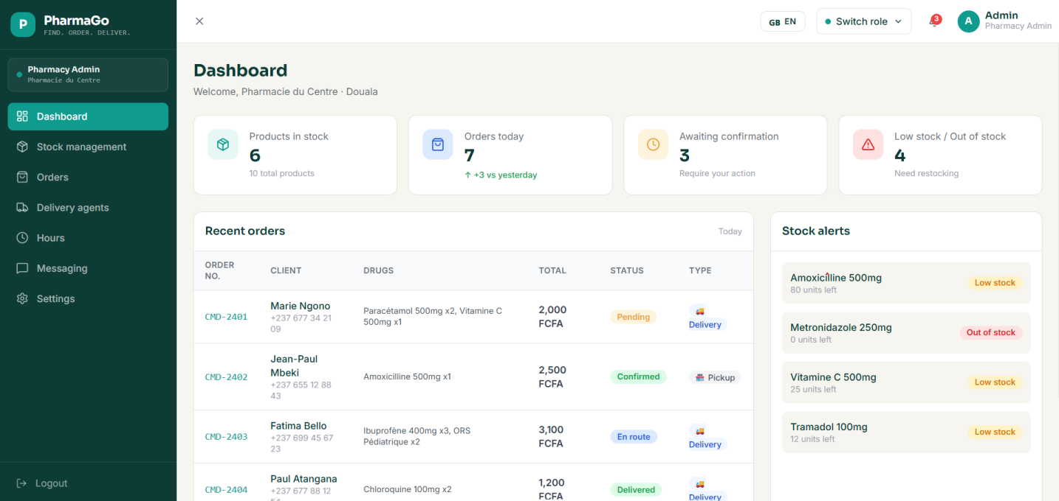
Figure 49: Pharmacy Admin Portal

- Pharmacist/Cashier can:
- View incoming orders.
- Verify prescriptions.
- Check the actual availability of requested medicines.
- Accept an order when the requested medicines are available.
- Reject an order when the medicines cannot be provided.
- Update the order status.
The pharmacist's confirmation is important because the stock displayed by the system is considered provisional until the pharmacy staff verifies the actual stock.
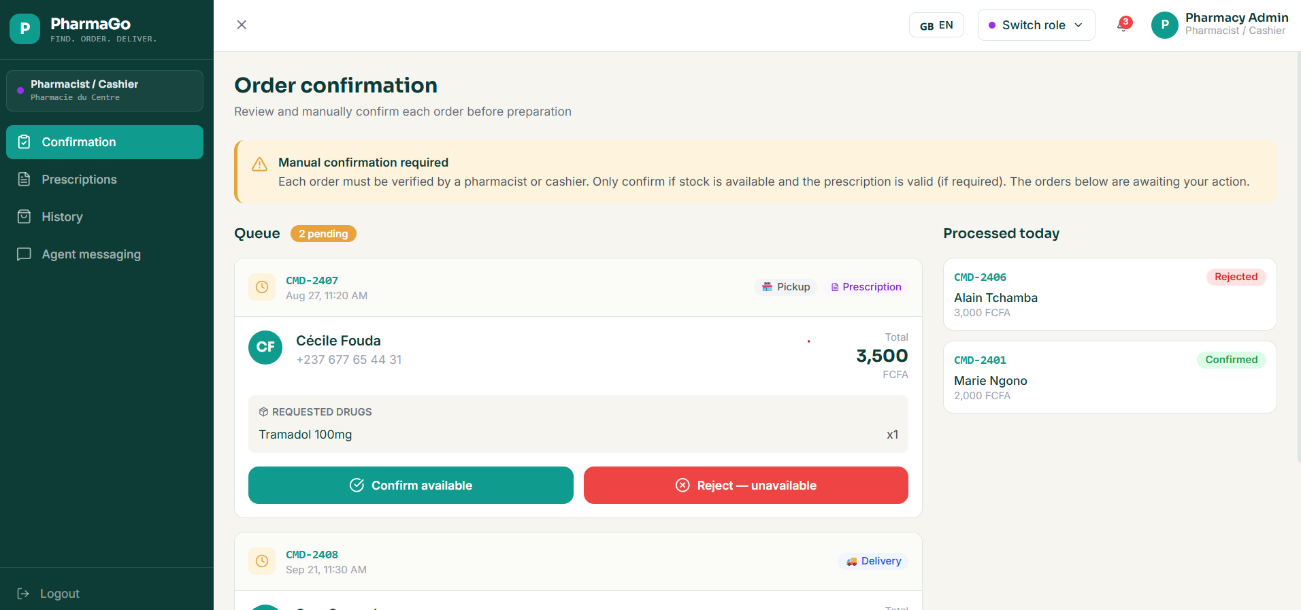
Figure 50 : Cashier/Pharmacist Portal

3. Platform Administration
The Platform Admin supervises the entire PharmaGo platform.
The administrator can:
- Manage user accounts.
- Manage registered pharmacies.
- Monitor orders and transactions.
- Manage platform-level disputes.
- View platform reports and analytics.
- Manage health-tip content.
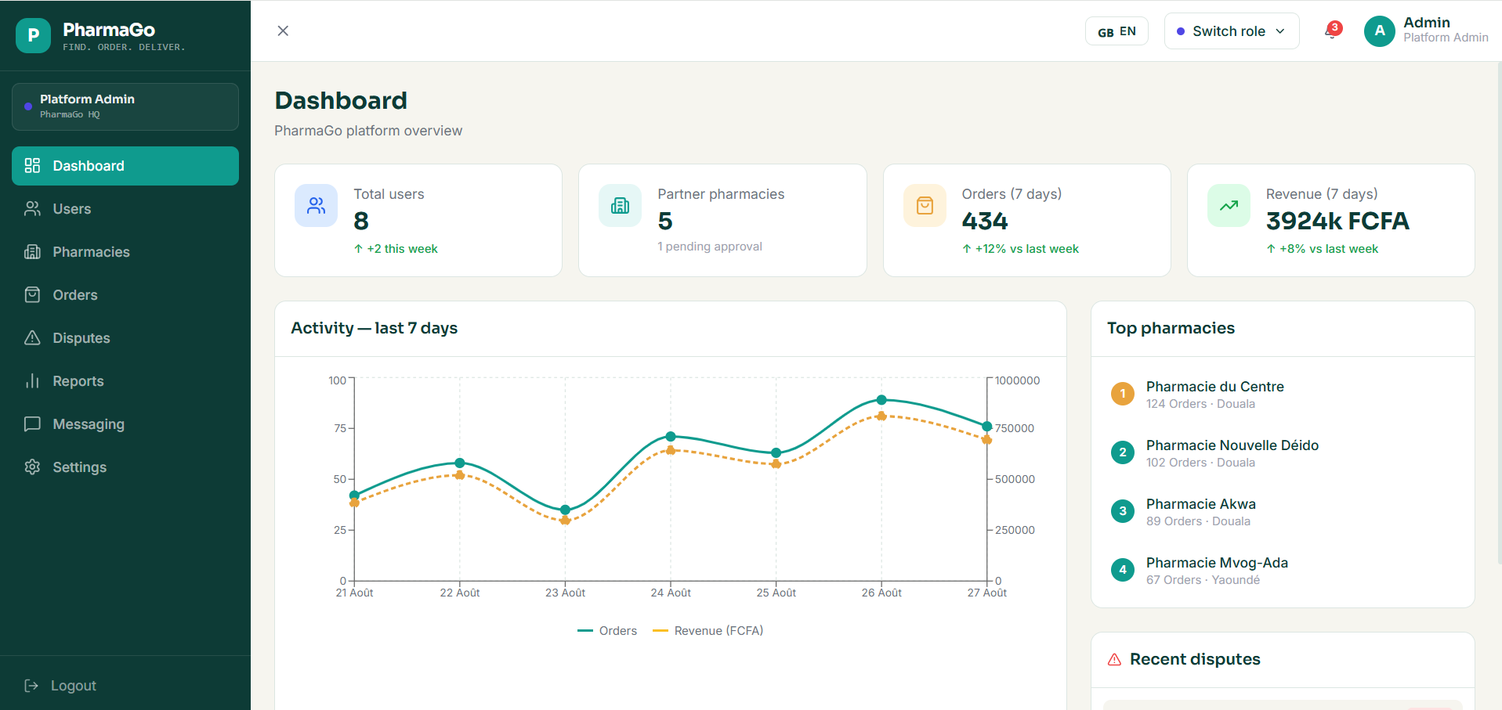
Figure 51 : Super Admin Portal

II. User Manual

1. Prerequisites
Before using PharmaGo, the following requirements should be available.

A. Client Mobile Application
The client needs:
- An Android smartphone.
- Android operating system.
- Internet connection through Wi-Fi or mobile data.
- GPS/location services enabled when searching for nearby pharmacies.
- A valid phone number for authentication.
- Camera or gallery access when uploading a prescription.
- A Mobile Money account if Mobile Money payment is selected.
The PharmaGo mobile application is developed with Flutter/Dart.

B. Web Administration Platform
Pharmacy staff and the Platform Admin need:
- A computer or laptop.
- A modern web browser such as Chrome, Edge or Firefox.
- Stable Internet connection.
- Valid PharmaGo staff credentials.
The administration platform is developed using React/Vite.

C. Backend
The PharmaGo backend requires:
- Node.js
- Express.js
- REST API
- JWT-based authentication
- PostgreSQL database
- Prisma ORM
- HTTPS communication

D. External Services
The system can communicate with:
- Google Maps API — pharmacy location, routes and travel time.
- Mobile Money payment service — Mobile Money payment processing.
- Notification service — order and status notifications.
- Object storage — prescription image storage.

E. Database
PharmaGo uses PostgreSQL as its main database.
The database stores information such as:
- Users
- Pharmacies
- Drugs
- Stock
- Orders
- Order items
- Prescriptions
- Payments
- Delivery agents
- Deliveries
- Notifications

CONCLUSION
This user guide has provided a comprehensive overview of our product's features, functionalities, and best practices for optimal use. By following the instructions and tips outlined in this document, you'll be well-equipped to maximize the potential of our product and streamline your workflow.

PERSPECTIVES

Having developed the core functionalities of PharmaGo, we plan to further improve the platform with the following features:
- Enhanced Mobile Money payment integration to provide secure and convenient payment processing for medicine orders and delivery services.
- Advanced user profile management to allow clients to manage their personal information, preferences, addresses, and order history.
- Health consultation and counseling services to facilitate communication between clients and qualified healthcare professionals when necessary.
- Daily health tips and guidance to provide users with useful health information while maintaining the advisory nature of the platform.
- Enhanced security and user verification mechanisms to strengthen account protection, verify pharmacy and healthcare-related users, and improve the overall reliability of the platform.
- Improved AI-assisted services to enhance the symptom-checking feature while maintaining appropriate limitations and encouraging users to consult qualified healthcare professionals when required.

GENERAL CONCLUSION

The project focused on the design and implementation of PharmaGo, an AI-assisted pharmacy stock management platform with geolocation-based drug search and delivery service. The project successfully resulted in the development of a digital solution designed to improve the visibility and management of pharmacy stocks while facilitating access to medicines for clients. Through features such as pharmacy and stock management, geolocation-based drug search, order processing, prescription management, pickup and delivery services, Mobile Money payment, and order tracking, PharmaGo provides a centralized platform connecting clients with pharmacies and supporting pharmacy personnel in managing their daily operations. The development process involved the analysis of user requirements, feasibility studies, UML modeling, system design, implementation, and testing following the 2TUP process. The project also required the integration of several technologies and external services, including Flutter, React/Vite, Node.js, Express.js, PostgreSQL, Prisma, Google Maps API, Gemini API, Supabase Storage, and Mobile Money services. Particular attention was given to role-based access control, database management, API integration, prescription handling, and the coordination of pickup and delivery services.The implementation of PharmaGo provided valuable practical experience in software engineering, mobile and web application development, database management, API integration, geolocation services, artificial intelligence, system security, UML modeling, and project management. It also strengthened our ability to analyze real-world problems and translate them into functional and technically coherent software solutions.

ANNEXES

BIBLIOGRAPHY
- IC3 (Internet Computing Core Certification) Course Material, 1st year, African Institute of Computer Science – Paul BIYA Technological Excellence Center, 2022, by Mrs. TCHOUTOUO.
- UML Course Material, 2nd year, African Institute of Computer Science – Paul BIYA Technological Excellence Center, 2025, by Mr. MESSIO Ulrich
- The Small Guide for Writing a thesis or Internship Report (1999), Charles de Gaulle University, Lille III, Faculty of Mathematics, Economic and Social Sciences.
- Scientific Writing Course Material, African Institute of Computer Science – Paul BIYA Technological Excellence Center, 2025, by Mrs. EBENYE.
- Database Design Course Material, African Institute of Computer Science – Paul BIYA Technological Excellence Center, 2025, by Mr. ASANE Derick
- Database Implementation Course Material, African Institute of Computer Science – Paul BIYA Technological Excellence Center, 2025, by Mr. MESSIO Ulrich
- OMG, OMG Unified Modelling Language 2.5, Object Management Group, March 2015, 794 pages.

WEBOGRAPHY
- Flutter: https://flutter.dev/ — Used to learn about Flutter and mobile application development. Consulted on 8 July 2026 at 10:24 (GMT+1).
- Dart: https://dart.dev/ — Used as a reference for the Dart programming language used in the mobile application. Consulted on 13 July 2026 at 14:17 (GMT+1).
- React: https://react.dev/ — Used to document ourselves on React for the web application. Consulted on 21 July 2026 at 09:43 (GMT+1).
- Vite: https://vite.dev/ — Used as a reference for the Vite development environment used in the web application. Consulted on 27 July 2026 at 16:08 (GMT+1).
- Node.js: https://nodejs.org/ — Used to learn about Node.js and the backend development environment. Consulted on 31 July 2026 at 11:36 (GMT+1).
- Express.js: https://expressjs.com/ — Used as a reference for developing the REST API with Express.js. Consulted on 5 August 2026 at 15:22 (GMT+1).
- PostgreSQL: https://www.postgresql.org/docs/ — Used to improve our knowledge of PostgreSQL and database management. Consulted on 11 August 2026 at 09:18 (GMT+1).
- Prisma: https://www.prisma.io/docs/ — Used as a reference for database access and ORM integration with PostgreSQL. Consulted on 16 August 2026 at 13:51 (GMT+1).
- Google Maps Platform: https://developers.google.com/maps — Used to learn about geolocation, pharmacy locations, routes, and travel-time calculations. Consulted on 22 August 2026 at 17:06 (GMT+1).
- Riverpod: https://riverpod.dev/ — Used to learn about state management in the Flutter application. Consulted on 3 September 2026 at 09:56 (GMT+1).
- TutorialsPoint UML: https://www.tutorialspoint.com/uml/index.htm — Used to learn more about UML and the creation of software engineering diagrams. Consulted on 15 September 2026 at 10:38 (GMT+1).
- Figma: https://www.figma.com/ — Used for designing and prototyping the application's user interfaces. Consulted on 19 September 2026 at 11:49 (GMT+1).
TABLE OF CONTENTS
Preamble - 3 -
Content Overview - 3 -
INTRODUCTION - 4 -
I. WELCOME AND INTEGRATION - 5 -
II. GENERAL PRESENTATION OF REALIZE - 6 -
III. ORGANISATION OF REALIZE - 8 -
A. Administrative Organization - 8 -
IV. HARDWARE AND SOFTWARE RESOURCES OF REALIZE - 10 -
V. BRIEF PRESENTATION OF THE PROJECT - 11 -
CONCLUSION - 12 -
Preamble - 15 -
Content Overview - 15 -
INTRODUCTION - 16 -
I. THEME PRESENTATION - 17 -
II. DESCRIPTION OF THE EXISTING SYSTEM - 18 -
III. LIMITATIONS OF THE EXISTING SYSTEM - 19 -
IV. PROBLEMATIC - 20 -
V. PROPOSED SOLUTION - 20 -
CONCLUSION - 21 -
Preamble - 23 -
Content Overview - 23 -
INTRODUCTION - 24 -
I. CONTEXT AND JUSTIFICATION - 25 -
II. OBJECTIVES OF THE PROJECT - 27 -
III. EXPRESSION OF NEEDS - 28 -
External Services - 29 -
IV. PROJECT ESTIMATION COST - 32 -
A. Software Resources - 32 -
C. Human Resources - 33 -
D. Global Estimation - 33 -
V. PROJECT CONSTRAINTS - 34 -
VI. LIST OF PARTICIPANTS AND DELIVERABLES - 34 -
1. LIST OF PARTICIPANTS - 34 -
2. DELIVRABLES - 35 -
CONCLUSION - 36 -
Preamble - 38 -
Content Overview - 38 -
INTRODUCTION - 39 -
I. COMPARATIVE METHODOLOGY - 40 -
A. Unified Process (UP) - 41 -
B. Two Track Unified Process (2TUP) - 42 -
CHARACTERISTICS OF 2TUP - 43 -
II. CHOICE OF THE ANALYSIS METHOD - 44 -
III. JUSTIFICATION OF THE ANALYSIS METHOD - 45 -
IV. MODELING OF THE PROPOSED SOLUTION - 46 -
CONCLUSION - 72 -
Preamble - 74 -
Content Overview - 74 -
INTRODUCTION - 75 -
I. TECHNICAL BRANCH - 76 -
A. CAPTURE OF TECHNICAL NEEDS - 76 -
a. Presentation Layer - 80 -
b. REST API Layer - 81 -
c. Controller/API Layer - 81 -
III. Advantages of the Architecture - 85 -
C. RELATED UML DIAGRAMS - 86 -
CONCLUSION - 92 -
Preamble - 94 -
Content Overview - 94 -
INTRODUCTION - 95 -
I. COMPONENT DIAGRAM - 96 -
II. DEPLOYMENT DIAGRAM - 99 -
III. TECHNICAL CHOICES - 102 -
e. Prisma ORM - 103 -
F. Supabase Storage - 104 -
CONCLUSION - 105 -
Preamble - 107 -
Content Overview - 107 -
INTRODUCTION - 108 -
I. TEST OF FUNCTIONALITIES - 109 -
1. What is Unit Testing - 109 -
2. Testing Strategy - 109 -
3. Tools Used - 109 -
4. Key Functionalities Tested - 109 -
II. TEST SHOWCASES - 111 -
a. Passing Unit Tests - 111 -
CONCLUSION - 113 -
Preamble - 115 -
Content Overview - 115 -
INTRODUCTION - 116 -
I. DESCRIPTION OF THE APPLICATION - 117 -
1. Clients - 117 -
2. Pharmacy Staff - 119 -
3. Platform Administration - 121 -
II. User Manual - 122 -
1. Prerequisites - 122 -
CONCLUSION - 124 -
BIBLIOGRAPHY - 128 -
WEBOGRAPHY - 129 -
TABLE OF CONTENTS - 130 -

